# 

# *Ag Caint Leatsa*

# Communication Policy, Gaelscoil na Mí

### Introductory Statement

The school and the family strive to be mutually supportive and respectful of each other and aim to work for the benefit of the child and their learning so that the child’s education can be effective. The family and home are central to the social and intellectual development of the child and the nurturing of good, moral values.

This policy was developed by the Board of Management and staff of Gaelscoil na Mí in consultation with parents and pupils in the 2022-23 school year. It’s purpose is to provide information and guidelines to parents and staff on parent/staff communication including formal and informal parent/staff meetings.

We know from research that children do better, behave better and are happier at school when parents and teachers work closely together and when parents are able to give their children support at home.

### The staff and Board of Management of Gaelscoil na Mí are committed to:

* Developing close effective links with parents
* Participating in meetings in a positive and respectful manner, affirming the central and fundamental role of parents as Primary Educators of their children
* Maintaining the ethos, values and distinctive character of Gaelscoil na Mí
* Supporting and facilitating the Parents Association
* Encouraging and facilitating the participation of parents in school life

### Parents are encouraged to:

* Develop close links with the school
* Collaborate with the school in developing the full potential of their children
* Share the responsibility of seeing that the school remains true to its ethos, values and distinctive character
* Become actively involved in the school and Parents Association

In all matters pertaining to the wellbeing and education of pupils, only the parents/legal guardians will be consulted by staff. It is essential that all parents and legal guardians are named on the enrolment form.

### Behaviour of all adults in the School

Positive and respectful communication is of high importance to our school. Adults in the school community (parents, staff, visitors) have a responsibility to ensure their own behaviour models the types of behaviour expected of children.

* All adults within the school are expected to speak to each other with respect, shouting or other aggressive tones are not acceptable. If any adult displays anger or aggression to another member of the school community, they may be asked to remove themselves from the building and/or school site. In severe cases, and if required, the Gardaí will be called
* The school will respect all children and parents’ right to privacy so staff should not be asked to speak about any child except your own nor will staff offer any details or information in relation to other children

### Things that the school needs to know to keep your children safe and healthy

* It is vital that the school is immediately informed if family events/situations occur that may cause anxiety to your child and could affect his/her education. Your first point of contact should always be your child’s class teacher
* The school should always know who is collecting your child. The school secretary should have a list of people and their contact information who you have authorised to collect your child. Should this change the onus is on you to inform the school secretary of the change. You can provide this information by email or by dropping in to the school office or updating details on Aladdin. Under no circumstances will a child be released to anyone unauthorised/unknown to the school. If, at any time, parents alter the pick-up arrangements for their child, the school should be given written authorisation by the parent immediately

### Structures in place to facilitate open communication and consultation with Parents

**Consultation throughout the year including:**

* Welcome day for new Junior Infants and their parents in May each year
* September class meetings. Teachers meet with the parents of their class toward the end of September to introduce themselves and briefly outline the curriculum, class rules and expectations for the year
* Parent/teacher meetings one-to-one in February (a short, written record of the meeting is maintained by each teacher)
* Class teachers / Special Education Teacher (SET) meet with parents whose children have additional educational needs in September/ October, January/ February and May/ June

**Written communication including:**

* Homework diary (2nd – 6th class), to inform parents about assigned homework, to confirm that homework has been completed and to relay messages between parents and teachers.
* Emails sent from class teachers to parents
* Emails sent from parents to class teachers
* Messages sent through Aladdin connect
* Regular newsletters keep parents up-to-date with school events, holidays, decisions taken to change current policies and procedures or to introduce new ones and other school concerns
* Class updates through Aladdin
* School report for each pupil at the end of each school year (shared via Aladdin)
* Text messages for general reminders (e.g school closures, coffee mornings)
* Some Special Education Needs (SEN) pupils may have a home school diary. This is not a means of reviewing academic/social progress but rather serves as a useful tool to share information between home and school
* Emails from principal to families

In general, communication sent from the school will be ‘paperless.’ Emails sent from the school will be sent to the email address(es) provided at enrolment, unless otherwise requested by parents. Any paper communication sent from the school will be sent to the child’s home address as given on the enrolment form, unless otherwise requested by parents.

**Other structures and processes include:**

* Parents are invited to discuss and contribute to the drafting and review of school policies through surveys and focus groups
* Parents are invited to events throughout the year e.g. Play days, Reading events, science exhibitions, Seachtain na Gaeilge, Friendship Week
* The Aladdin Connect app. We encourage all parents to utilise this app. Through this app contact details can be updated, consent can be sought, absences can be explained, school reports can be viewed, payments can be made

### Procedures for parents to initiate communication with the school

If a parent wishes to consult with a teacher, they can contact the teacher to arrange a suitable time. In the event that a parent has a complaint, Appendix 1 outlines the procedures to be followed.

Classes begin at 8:50am and finish at 1:30pm (infants) and 2.30pm (1st-6th) and this time should not be interrupted. Meetings with the class staff at the class door or in the yard to discuss a child’s concern/progress are discouraged on several grounds:

* Staff cannot adequately supervise their class while at the same time speaking to a parent
* It is difficult to be discreet when so many children are standing close by
* It can be embarrassing for a child when their parent is talking to staff at a classroom door

On some rare occasions a parent may need to speak to a staff member urgently. Sometimes these meetings need to take place without prior notice. The Principal will aim to facilitate such meetings making every effort to ensure that the children in the class do not lose out on any of the teaching/learning time.

If the principal or class teacher is unavailable at short notice we ask that parents leave an outline of what they wish to discuss with the secretary. The continued presence of parents in the school building and on school grounds until such time as the staff member is available is not welcome. The relevant member of staff will contact the parents as soon as is possible.

If parents wish to drop in lunch boxes, sports gear during class time etc, this can be done through the secretary’s office so that learning is not disrupted.

Meetings with the principal can be arranged through the school office. When concerns relate to classroom matters parents are expected to engage with the class teacher first and foremost.

“Town hall” style meetings will not be facilitated with any group of parents wishing to raise concerns.

### Online and Social Media Communication

Gaelscoil na Mí has a website [www.gaelscoilnami.ie](http://www.gaelscoilnami.ie), a Facebook account and an Instagram page. Parents are encouraged to visit these sites regularly to keep up to date on school matters, comment and contribute to posts and share information to help publicise the school and the achievements of our children.

The school’s name or anything that identifies the school should not be used on online or on social media (for example class Facebook page which might be set up by parents) by members of the public including parents without express written permission from the principal or Board of Management. Gaelscoil na Mí will request removal of any online or social media sites that are not approved by the school.

We are proud of the high standards in our school. In order to defend our school reputation and that of our staff, any commentary which may be deemed as slanderous in any forum will not be tolerated and the school will pursue all steps up to and including legal action against those responsible.

### Communication between staff

### Staff meetings take place once a month. All members of teaching staff are expected to attend and non-teaching staff must attend on request of the principal.

### Staff also have three other scheduled hours during each month (Croke park hours) which are allocated to planning.

### Staff operate a Whatsapp group which is used for sharing daily school updates, social news and events.

Staff emails and Aladdin noticeboard are also in use for staff communication.

### Communication between School/Board/PAC

### Representatives of the Board of Management and the Parents Association Committee meet annually.

### There is a teacher representative on the Board of Management who attends meetings monthly.

### There is a teacher representative on the Parents Association Committee who attends meetings. This representative also brings items back to the staff/Principal for discussion.

### Email communication between School and PAC is generally limited to:

### Principal to Chairperson

### Treasurer to Treasurer

### With some necessary contact made between one member of the PAC and the school secretary (including photos for website etc).

### Communication with outside agencies

### Gaelscoil na Mí has enjoyed and benefited from links with state agencies since 2011. These include:

### NEPS / NCSE / SENO / HSE / Tusla/ CAMHS/ Primary Care teams

### Gaelscoil na Mí also aims to make links with the community through:

### Links with local schools (Principal meetings, pupil events)

### Links with the community Gardaí

### Links with local events

### Rent of school hall

### Communication through the school office

### The school phone number is 01-8353480 and the email address is [oifig@gaelscoilnami.ie](mailto:oifig@gaelscoilnami.ie/). The school office is open from 8.45am - 2.30pm each day with the exception of a lunchtime break of 30 minutes.

All visitors must report to the school reception and identify themselves and their business to the school secretary/ staff member.

Parents will be informed of office closures in advance when possible.

### There may be occasions where a parent is trying to contact the school by phone and/or email and are not receiving a response. Office hours are limited and the secretary is not always at the desk. We ask for patience during these times.

### Communication by email - response time

### Emails to the school office are read and responded to during working hours; 8.50am - 2.30pm.

### Response times to emails from the school secretary can vary depending on the demands in the office at any given time. It is considered reasonable that 3-5 school days are allowed for a response (except for holiday periods during which email is only checked intermittently).

### Response times to emails to the Principal can also vary greatly depending on the demands at any given time. Priority must be given to the pupils, staff and overall running of the school. A response time of 5-7 school days is reasonable.

### Teachers are in class during the day and will not have time to access emails. They may be engaged in planning, meetings or personal matters after school hours and so again 3-5 school days is a reasonable response time.

Teaching staff (including the principal) are instructed to not have their work email on their personal phone and to not respond to emails after 5.30pm on school days as a courtesy to their colleagues.

# Parent/Teacher Meetings

### The purpose of the Parent/Teacher meeting is:

* To establish and maintain good communication between the school and parents
* To let parents know how their children are progressing in school
* To help teachers/parents get to know the children better as individuals
* To help children realise that home and school are working together
* To share with the parent the problems and difficulties the child may have in school
* To review with the parent the child’s experience of schooling
* To learn more about the child from the parent’s perspective
* To get general feedback from the parents regarding the school
* To identify ways in which parents can help their children
* To negotiate jointly decisions about the child’s education

### Organisation of Parent/Teacher meetings

Formal Parent/Teacher meetings will be held once a year for all classes, usually in February prior to mid-term break. If a parent wishes to arrange an additional meeting at any stage during the year to discuss their child, they may do so by contacting the school secretary or their child’s class teacher directly.

Gaelscoil na Mí uses prepared guidelines to give structure to the meetings. These can vary from teacher to teacher but must include feedback on attendance, behaviour, punctuality, standardised test results (where applicable) and overview of progress through the curriculum. Parent/Teacher meetings may take place in classrooms, offices, support rooms or in the school hall. Each meeting is allocated a 10-minute time slot which parents can book through the Aladdin Connect app. If a longer meeting is required these should be scheduled for another day.

To facilitate the operation of the school and the needs of children and other parents, it is important that meetings should be kept to the allocated time. Times of meetings are agreed beforehand and should be adhered to so that all parents are seen on time in so far as is possible.

### Planning meetings for Individual Education Plans/ Individual Plans

Formal parent/staff meetings relating to a child’s **Individual Education Plan/ Individual Plan** will take place in September/October. If a parent wishes to arrange a meeting at any stage during the year to discuss their child, they may do so by prior appointment. **In the case of separated/ divorced parents, Gaelscoil na Mí will facilitate requests made by parents to meet their child’s teacher(s) individually for parent/teacher meetings.**

# School Reports

Gaelscoil na Mí produces formal reports for reporting to parents on students’ progress and achievement at school annually in the third term using report card templates as required by the National Council of Curriculum and Assessment (www.ncca.ie). The reports are issued through the Aladdin app in the week prior to school closing for the summer break to allow parents time to ask for clarification with the teacher on anything contained in their child’s report. Report cards are written as Gaeilge and will cover;

* The child’s learning and achievement across the curriculum
* The child’s learning dispositions
* The child’s social and personal development
* Ways in which parents can support their child’s learning

Reports for children in their final year of primary school (sixth class) will be in the form of an **Education Passport**. These support the transfer of pupil information from primary to post-primary and follow a standard template.

# Safety, Health and Welfare at Work

The Safety, Health and Welfare at Work Act became operative on 1 November 1989. It is an important piece of legislation for BoMs and for those who work in schools, as schools and colleges were brought under the scope of safety legislation for the first time.

It is recognised that school staff may be at risk from violence in the form of verbal abuse, threats, assaults or other forms of intimidation. This behaviour may come from pupils, parents, guardians, other staff members or intruders.

In this respect, all staff should be aware of **DES Circular 40/97** which deals with the procedures to follow if they feel they have been subjected to any of the above behaviours.

**This policy was approved by the Board of Management and implemented immediately.**

**Cathaoirleach: Cormac Mc Cashin**

**Príomhoide: Clár Ní Mhaoláin**

**Dáta: 26/04/23**

**APPENDIX 1: Complaints Procedure**

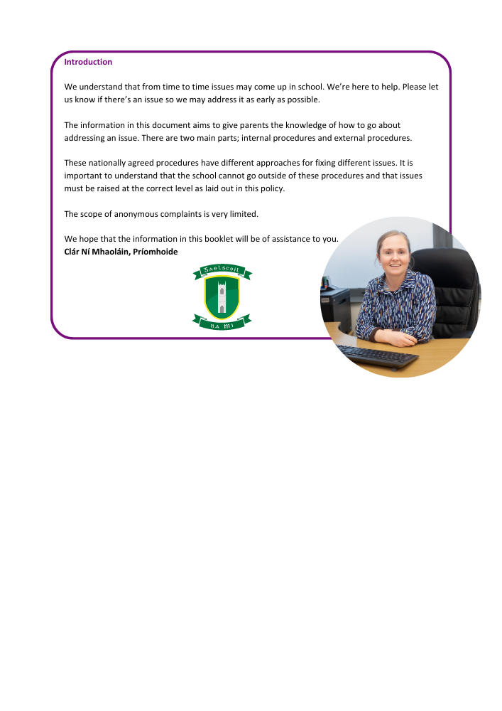

**Internal Procedures**

It is important that an issue is addressed at the right level. For example, a classroom issue should first be raised with the class teacher instead of with the Board of Management as a first step.

**A)** If you're worried about your child at school or you have a complaint about the school, your child's class teacher is the best person to approach first for an informal discussion. To do this, contact the school office and organise an appointment or phone call for an informal discussion. If you are not happy after that discussion, you can at that point talk to the principal (who may ask you to speak to another member of staff, depending on the nature of the issue).

**B)** If your complaint is about a teacher, please view the procedure on the next page.

**C)** If your complaint is about a staff member (who is not the principal), you should contact the school principal. Contact the school office to make an appointment with the principal. If you are not happy with the response of the principal you can address the issue in writing with the Board of Management by sending a letter addressed to ‘An Cathaoirleach’ at the school address only.

**D)** Complaints regarding the principal should be directed to the Board of Management by sending a letter addressed to ‘An Cathaoirleach’ at the school address only. Please note that correspondence will come to you after the next Board of Management meeting and this may be a number of weeks (the board generally meets 6-7 times between September and June).

**Parental Complaints Procedure**

This Complaints Procedure, agreed by the teachers’ union and management bodies, provides a mechanism for dealing with parental complaints against a teacher as set out in Section 28 of the Education Act 1998.

The Board of Management of Gaelscoil na Mí follows the ‘Governance Manual for Primary Schools’ as laid down by the Dept. of Education in all matters of business. Therefore 15(c) (Pg29) Disclosure of Interest/integrity of Board Proceedings deems it necessary for any member of the Board who is personally subject of a matter which is before the board to withdrawn from the deliberations.

**Relationship to School Ethos**

The school promotes positive home – school contacts and endeavours to enhance the self-esteem of everyone within the school community. The policy contributes towards those ideals.

**Aims/Objectives**

• To foster fruitful and trusting relationships between school and parents

• To afford parents an opportunity to express opinions/grievances through the framework of a defined procedure

• To minimize the opportunity for conflict by providing parents an opportunity to liaise with the class teacher

**Introduction**

Only those complaints about teachers which are written and signed by parents/guardians of pupils may be investigated formally by the Board of Management, except where those complaints are deemed by the Board to be:

• matters of professional competence and which are to be referred to the Department of Education

• frivolous or vexatious and which do not impinge on the work of a teacher in a school

• complaints in which either party has recourse to law or to another existing procedure

Unwritten complaints not in the above categories may be processed informally as set out in Stage 1 of this procedure.

**Stage 1**

**1.1** A parent/guardian who wishes to make a complaint must contact their child’s class teacher outlining their concern, receive confirmation of a mutually agreed time to meet with the class teacher and approach the meeting with a view to resolving the complaint.

**1.2** Where the parent/guardian is unable to resolve the complaint with the class teacher they must contact the Principal outlining their concern, receive confirmation of a mutually agreed time and approach the meeting with a view to resolving the complaint.

**1.3** If the complaint is still unresolved the parent/guardian should proceed to Stage 2 of these procedures

**Stage 2**

2.1 If the complaint is still unresolved and the parent/guardian wishes to pursue the matter further she/he should lodge the complaint in writing with the Chairperson of the Board of Management (by sending a letter addressed to ‘An Cathaoirleach’ at the school address only).

2.2 The Chairperson should bring the precise nature of the written complaint to the notice of the teacher and seek to resolve the matter between the parties within 5 days of receipt of the written complaint.

**Stage 3**

3.1 If the complaint is not resolved informally, the Chairperson should, subject to the general authorisation of the Board and except in those cases where the Chairperson deems the particular authorisation of the Board to be required:

a. Supply the teacher with a copy of the written complaint; and

b. Arrange a meeting with the teacher and, where applicable, the Principal teacher with a view to resolving the complaint. Such a meeting should take place within 10 days of receipt of the written complaint.

**Stage 4**

4.1 If the complaint is still not resolved the Chairperson should make a formal report to the Board within 10 days of the meeting referred to in 3.1 (b)

4.2 If the Board considers that the complaint is not substantiated the teacher and the complainant should be so informed within 3 days of the Board meeting.

4.3 If the Board considers that the complaint is substantiated or that it warrants further investigation it proceeds as follows:

a. The teacher should be informed that the investigation is proceeding to the next stage;

b. The teacher should be supplied with a copy of any written evidence in support of the complaint;

c. The teacher should be requested to supply a written statement to the Board in response to the complaint;

d. The teacher should be afforded an opportunity to make a presentation of the case to the Board. The teacher would be entitled to be accompanied and assisted by a friend ay any such meeting;

e. the Board may arrange a meeting with the complainant if it considers such to be required. The complainant would be entitled to be accompanied and assisted by a friend at any such meeting; and

f. The meeting of the Board of Management referred to in (d) and (e) will take place within 10 days of the meting referred to in 3.1 (b)

**Stage 5**

5.1 When the Board has completed its investigation, the Chairperson should convey the decision of the Board in writing to the teacher and the complainant within 5 days of the meeting of the Board.

5.2 The decision of the Board shall be final.

**Please note;**

• In this agreement ‘days’ means days that the school is open and pupils are in attendance.

• Complaints will only be processed by the Board of Management during school terms and not during school holidays or closures

• Correspondence to the Board of Management will only be accepted and responded to by post. All correspondence should be addressed to: An Cathaoirleach, Gaelscoil na Mí, Cill Dhéagláin Thiar, Cill Dhéagláin, Co na Mí.

• It is a condition of enrolment of Gaelscoil na Mí that parents / guardians agree to follow this policy in its entirety

**Implementation**

This policy will be implemented immediately and will be reviewed in September each year.

**Success Criteria**

• Swift and efficient resolution of grievances

• Parent/Teacher satisfaction

• Positive school community feedback

• Reviews of school policies as issues arise.

--------------------------------------------------------------------------------------------------------------------------

**External Procedures**

If the issue has not been resolved having followed the steps laid out in A – D on page 1, you may look to resolve the issue by using the External Procedures.

**Complaints about teachers**

**The Teaching Council** provides a formal process for issues relating to registered teachers to be investigated. Details on this process are available in a document called ‘How to make a complaint about a registered teacher’ on their website: [www.teachingcouncil.ie](http://www.teachingcouncil.ie)

**General Complaints**

**An Foras Pátrúnachta**

Our school patron may be able to investigate the issue if **(i)** the Internal Procedures have been followed to completion or **(ii)** if the issue relates to the Board of Management itself.

To do this, send a letter to: An Foras Pátrúnachta, Block K3, Maynooth Business Campus, Maynooth, Co. Kildare.

**Office of the Ombudsman for Children**

The Office of the Ombudsman for Children provides an independent and impartial complaint handling service. The Ombudsman for Children can investigate complaints relating to the administrative actions of a school recognised by the Department of Education provided the complainant has firstly and fully followed the school’s complaints procedures. The key criterion for any intervention by the Ombudsman for Children is that the action complained of has or may have adversely affected the child. More information about the Ombudsman for Children can be obtained on www.oco.ie/ or by calling them on 1800 20 20 40.