

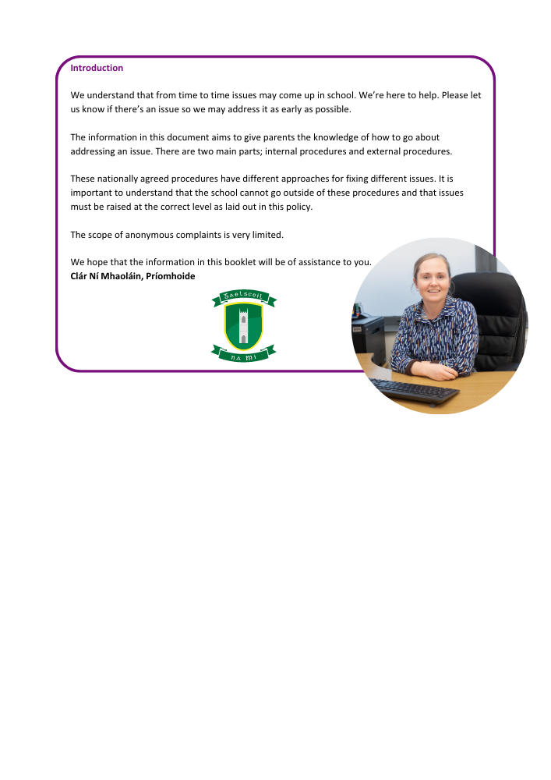

**Internal Procedures**

It is important that an issue is addressed at the right level. For example, a classroom issue should first be raised with the class teacher instead of with the Board of Management as a first step.

**A)** If you're worried about your child at school or you have a complaint about the school, your child's class teacher is the best person to approach first for an informal discussion. To do this, contact the school office and organise an appointment or phone call for an informal discussion. If you are not happy after that discussion, you can at that point talk to the principal (who may ask you to speak to another member of staff, depending on the nature of the issue).

**B)** If your complaint is about a teacher, please view the procedure on the next page.

**C)** If your complaint is about a staff member (who is not the principal), you should contact the school principal. Contact the school office to make an appointment with the principal. If you are not happy with the response of the principal you can address the issue in writing with the Board of Management by sending a letter addressed to ‘An Cathaoirleach’ at the school address.

**D)** Complaints regarding the principal should be directed to the Board of Management by sending a letter addressed to ‘An Cathaoirleach’ at the school address. Please note that correspondence will come to you after the next Board of Management meeting and this may be a number of weeks (the board generally meets 6-7 times between September and June).

**Parental Complaints Procedure**

This Complaints Procedure, agreed by the teachers’ union and management bodies, provides a mechanism for dealing with parental complaints against a teacher as set out in Section 28 of the Education Act 1998.

The Board of Management of Gaelscoil na Mí follows the ‘Governance Manual for Primary Schools’ as laid down by the Dept. of Education in all matters of business. Therefore 15(c) (Pg29) Disclosure of Interest/integrity of Board Proceedings deems it necessary for any member of the Board who is personally subject of a matter which is before the board to withdrawn from the deliberations.

**Relationship to School Ethos**

The school promotes positive home – school contacts and endeavours to enhance the self-esteem of everyone within the school community. The policy contributes towards those ideals.

**Aims/Objectives**

• To foster fruitful and trusting relationships between school and parents

• To afford parents an opportunity to express opinions/grievances through the framework of a defined procedure

• To minimize the opportunity for conflict by providing parents an opportunity to liaise with the class teacher

**Introduction**

Only those complaints about teachers which are written and signed by parents/guardians of pupils may be investigated formally by the Board of Management, except where those complaints are deemed by the Board to be:

• matters of professional competence and which are to be referred to the Department of Education

• frivolous or vexatious and which do not impinge on the work of a teacher in a school

• complaints in which either party has recourse to law or to another existing procedure

Unwritten complaints not in the above categories may be processed informally as set out in Stage 1 of this procedure.

**Stage 1**

**1.1** A parent/guardian who wishes to make a complaint must contact their child’s class teacher outlining their concern, receive confirmation of a mutually agreed time to meet with the class teacher and approach the meeting with a view to resolving the complaint.

**1.2** Where the parent/guardian is unable to resolve the complaint with the class teacher they must contact the Principal outlining their concern, receive confirmation of a mutually agreed time and approach the meeting with a view to resolving the complaint.

**1.3** If the complaint is still unresolved the parent/guardian should proceed to Stage 2 of these procedures

**Stage 2**

2.1 If the complaint is still unresolved and the parent/guardian wishes to pursue the matter further she/he should lodge the complaint in writing with the Chairperson of the Board of Management by sending a letter addressed to ‘An Cathaoirleach’ at the school address.

2.2 The Chairperson should bring the precise nature of the written complaint to the notice of the teacher and seek to resolve the matter between the parties within 5 days of receipt of the written complaint.

**Stage 3**

3.1 If the complaint is not resolved informally, the Chairperson should, subject to the general authorisation of the Board and except in those cases where the Chairperson deems the particular authorisation of the Board to be required:

a. Supply the teacher with a copy of the written complaint; and

b. Arrange a meeting with the teacher and, where applicable, the Principal teacher with a view to resolving the complaint. Such a meeting should take place within 10 days of receipt of the written complaint.

**Stage 4**

4.1 If the complaint is still not resolved the Chairperson should make a formal report to the Board within 10 days of the meeting referred to in 3.1 (b)

4.2 If the Board considers that the complaint is not substantiated the teacher and the complainant should be so informed within 3 days of the Board meeting.

4.3 If the Board considers that the complaint is substantiated or that it warrants further investigation it proceeds as follows:

a. The teacher should be informed that the investigation is proceeding to the next stage;

b. The teacher should be supplied with a copy of any written evidence in support of the complaint;

c. The teacher should be requested to supply a written statement to the Board in response to the complaint;

d. The teacher should be afforded an opportunity to make a presentation of the case to the Board. The teacher would be entitled to be accompanied and assisted by a friend ay any such meeting;

e. the Board may arrange a meeting with the complainant if it considers such to be required. The complainant would be entitled to be accompanied and assisted by a friend at any such meeting; and

f. The meeting of the Board of Management referred to in (d) and (e) will take place within 10 days of the meting referred to in 3.1 (b)

**Stage 5**

5.1 When the Board has completed its investigation, the Chairperson should convey the decision of the Board in writing to the teacher and the complainant within 5 days of the meeting of the Board.

5.2 The decision of the Board shall be final.

**Please note;**

• In this agreement ‘days’ means days that the school is open and pupils are in attendance.

• Complaints will only be processed by the Board of Management during school terms and not during school holidays or closures

• Correspondence to the Board of Management will only be accepted and responded to by post. All

correspondence should be addressed to An Cathaoirleach, Gaelscoil na Mí, Cill Dhéagláin Thiar, Cill Dhéagláin, Co na Mí.

• It is a condition of enrolment of Gaelscoil na Mí that parents / guardians sign to accept and agree to follow this policy in its entirety

**Implementation**

This policy will be implemented immediately and will be reviewed in September each year.

**Success Criteria**

• Swift and efficient resolution of grievances

• Parent/Teacher satisfaction

• Positive school community feedback

• Reviews of school policies as issues arise.

--------------------------------------------------------------------------------------------------------------------------

**External Procedures**

If the issue has not been resolved having followed the steps laid out in A – D on page 1, you may look to resolve the issue by using the External Procedures.

**Complaints about teachers**

**The Teaching Council** provides a formal process for issues relating to registered teachers to be investigated. Details on this process are available in a document called ‘How to make a complaint about a registered teacher’ on their website: [www.teachingcouncil.ie](http://www.teachingcouncil.ie)

**General Complaints**

**An Foras Pátrúnachta**

Our school patron may be able to investigate the issue if **(i)** the Internal Procedures have been followed to completion or **(ii)** if the issue relates to the Board of Management itself.

To do this, send a letter to: An Foras Pátrúnachta, Block K3, Maynooth Business Campus, Maynooth, Co. Kildare.

**Office of the Ombudsman for Children**

The Office of the Ombudsman for Children provides an independent and impartial complaint handling service. The Ombudsman for Children can investigate complaints relating to the administrative actions of a school recognised by the Department of Education provided the complainant has firstly and fully followed the school’s complaints procedures. The key criterion for any intervention by the Ombudsman for Children is that the action complained of has or may have adversely affected the child. More information about the Ombudsman for Children can be obtained on www.oco.ie/ or by calling them on 1800 20 20 40.

This policy was approved by the Board of Management.

**Sínithe:** Cormac Mc Cashin **Sínithe:** Clár Ní Mhaoláin

(Cathaoirleach) (Príomhoide)

**Dáta:** 03.05.23