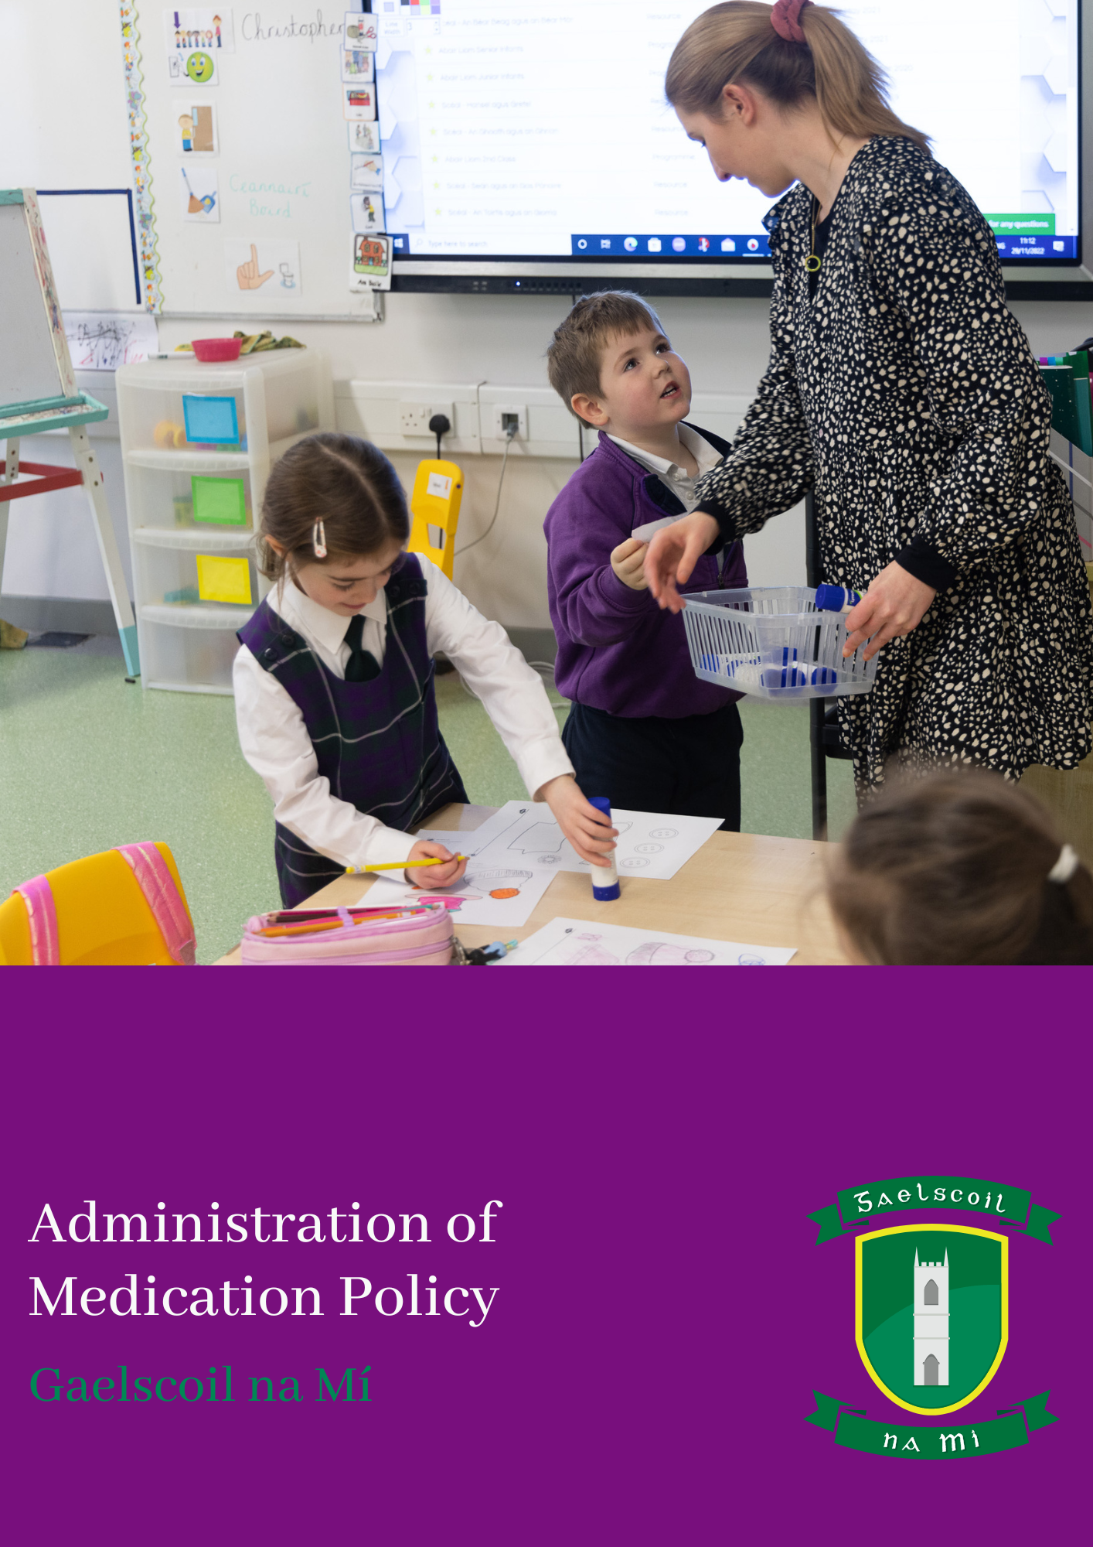

**Gaelscoil na Mí**

**Administration of Medication Policy**

**Introduction**

The following Administration of Medication Policy has been formulated by the staff and Board of Management of Gaelscoil na Mí.

**Rationale**

The policy as outlined was put in place to;

* Clarify areas of responsibility
* To give clear guidance about situations where it is not appropriate to administer medicines
* To indicate the limitations to any requirements which may be notified to teachers and school staff
* To outline procedures to deal with a pupil with a nut allergy in our school
* Safeguard school staff that are willing to administer medication
* Protect against possible litigation

**Relationship to School Ethos**

The school promotes positive home-school contacts, not only in relation to the welfare of children, but in relation to all aspects of school life. This policy is in keeping with the school ethos through the provision of a safe, secure and caring school environment and the furthering of positive home-school links.

**Aims of this Policy**

The aims and objectives of the policy can be summarised as follows;

* Minimise health risks to children and staff on the school premises
* Fulfil the duty of the BoM in relation to Health and Safety requirements
* Provide a framework within which medicines may be administered in cases of emergency or in instances where regularised administration has been agreed with parents/guardians

**In–School Procedures**

Parents are required to complete a Health/Medication form when enrolling their child(ren) in the school. No teacher is obliged to administer medicine or drugs to a pupil and any teacher willing to do so works under the controlled guidelines outlined below.

* Prescribed medicines will only be administered after parents of the pupil concerned have written to the BoM requesting the Board to authorise a member of the teaching staff to do so. Under no circumstance will non-prescribed medicines be either stored or administered in the school. The Board will seek indemnity from parents in respect of any liability arising from the administration of medicines
* The school generally advocates the self-administration (e.g. inhalers) of medicine under the supervision of a responsible adult, exercising the standard of care of a prudent parent. No medicines are stored on the school premises. A small quantity of prescription drugs will be stored in the Administration Office if a child requires self-administering on a daily basis and parents have requested storage facilities. Parents are responsible for the provision of medication and notification of change of dosage
* Teachers have a professional duty to safeguard the health and safety of pupils, both when they are authorised to be on the school premises and when they are engaged in authorised school activities elsewhere
* The Board of Management requests parents to ensure that teachers be made aware in writing of any medical condition suffered by any child in their class. This does not imply a duty upon teachers personally to undertake the administration of medicines or drugs

**Long-Term Health Problems**

Where there are children with long-term health problems in school, proper and clearly understood arrangements for the administration of medicines must be made with the Board of Management. This is the responsibility of the parents/guardians. It would include measures such as self-administration, administration under parental supervision or administration by school staff.

**Life Threatening Condition**

Where children are suffering from life threatening conditions, parents/guardians must clearly outline, in writing, what should be done in a particular emergency situation, with particular reference to what may be a risk to the child (Appendix 3). If emergency medication is necessary, arrangements must be made with the Board of Management. A letter of indemnity must be signed by the parents in respect of any liability that may arise regarding the administration of medication.

**Guidelines for the Administration of Medicines**

1. The parents of the pupil with special medical needs must inform the Board of Management in writing of the condition, giving all the necessary details of the condition. The request must also contain written instruction of the procedure to be followed in administering the medication (Appendix 1, 2 or 3)
2. Parents must write requesting the Board of Management to authorise the administration of the medication in school
3. Where specific authorisation has been given by the Board of Management for the administration of medicine, the medicines must be brought to school by the parent/guardian/designated adult
4. A written record of the date and time of administration must be kept by the person administering it (Appendix 4)
5. Parents/Guardians are responsible for ensuring that emergency medication is supplied to the school and replenished when necessary
6. Emergency medication must have exact details of how it is to be administered
7. The BoM must inform the school’s insurers accordingly
8. Parents are further required to indemnify the Board of Management and members of the staff in respect of any liability that may arise regarding the administration of prescribed medicines in school
9. All correspondence related to the above are kept in the school

**Medicines**

* Non-prescribed medicines will neither be stored nor administered to pupils in school
* Teachers/SNAs in the school will only administer prescribed medication when arrangements have been put in place as outlined above
* Arrangements for the storage of certain emergency medicines, which must be readily accessible at all times, must be made with the Principal
* A teacher/SNA must not administer any medication without the specific authorisation of the Board of Management
* The prescribed medicine must be self-administered if possible, under the supervision of an authorised Teacher/SNA if not the parent
* No teacher/SNA can be required to administer medicine or drugs to a pupil
* In an emergency situation, qualified medical assistance will be secured at the earliest opportunity and the parents contacted
* It is not recommended that children keep medication in bags, coats, etc.
* Where possible, the parents should arrange for the administration of prescribed medicines outside of school hours

**The following guidelines are in place with regard to pupils with a Nut Allergy**

1. Staff dealing with the pupil do not eat nuts or any item with nut trace
2. Advise children not to offer or exchange foods, sweets, lunches etc
3. If going off-site, medication must be carried

In the event the pupil comes in contact with nuts, it is only in the event of anaphylactic shock should the pen be administered. The pen is stored in the filing cabinet in main office for children who need the assistance of an adult to administer it and in the classroom filing cabinet for children who can self-administer. Before or immediately after the pen has been administered, an ambulance must be called.

**Indicators of shock include**

Symptoms of shock can include, wheezing, severe difficulty breathing and gastrointestinal symptoms such as abdominal pain, cramps, vomiting and diarrhoea.

**Emergencies**

In the event of an emergency, teachers should do no more than is necessary and appropriate to relieve extreme distress or prevent further and otherwise irreparable harm. Qualified medical treatment should be secured in emergencies at the earliest opportunity.

Where no qualified medical treatment is available, and circumstances warrant immediate medical attention, designated staff members may take a child into Accident and Emergency without delay. Parents will be contacted simultaneously. All costs incurred are the responsibility of the parents/guardians.

In addition, parents must ensure that teachers are made aware in writing of any medical condition which their child is suffering from. For example children who are epileptics, diabetics etc. may have a seizure at any time and teachers must be made aware of symptoms in order to ensure that treatment may be given by appropriate persons.

Written details are required from the parents/guardians outlining the child’s personal details, name of medication, prescribed dosage, whether the child is capable of self-administration and the circumstances under which the medication is to be given. Parents should also outline clearly proper procedures for children who require medication for life threatening conditions.

The school maintains an up to date register of contact details of all parents/guardians including emergency numbers. This is updated in September of each new school year.

**First Aid Boxes**

A full medical kit is taken when children are engaged in out of school activities such as tours football/hurling games and athletic activities.

A first aid box is kept in the front office, the staffroom and in the small hallway at the back door. Each box contains anti-septic wipes, anti-septic bandages, sprays, steri-strips, cotton wool, scissors etc.

A defibrillator is available in the front hall of the school.

**General Recommendations**

We recommend that any child who shows signs of illness should be kept at home; requests from parents to keep their children in at lunch break are not encouraged. A child too sick to play with peers should not be in school.

**Roles and Responsibilities**

The BoM has overall responsibility for the implementation and monitoring of the school policy on Administration of Medication. The Principal is the day to day manager of routines contained in the policy with the assistance of all staff members. The Deputy Principal is the Safety Representative and the maintenance and replenishment of First Aid Boxes is a post of responsibility within the middle management structure in the school.

**Success Criteria**

The effectiveness of the school policy in its present form is measured by the following criteria;

* Compliance with Health and Safety legislation
* Maintaining a safe and caring environment for children
* Positive feedback from parents/teachers
* Ensuring the primary responsibility for administering remains with parents/guardians

**Appendices**

* **Appendix 1:** Medical Condition and Administration of Medicines
* **Appendix 2:** Allergy Details
* **Appendix 3:** Emergency Procedures
* **Appendix 4:** Record of administration of Medicines

**Ratification and Review**

This policy will be reviewed in the event of incidents or on the enrolment of child/children with significant medical conditions, but no later than 2 years from the date below.

**SÍNITHE**

Cormac Mc Cashin Clár Ní Mhaoláin

__________________________ __________________________

*Cathaoirleach Príomhoide*

**Dáta: 10.05.23**

**APPENDIX 1**

**Medical Condition and Administration of Medicines**

|  |  |
| --- | --- |
| **PUPIL DETAILS** | |
| Child’s name |  |
| Address |  |
| Date of Birth |  |
| **EMERGENCY CONTACTS** | |
| Name |  |
| Contact number |  |
| Name |  |
| Contact number |  |
| Name |  |
| Contact number |  |
| Name |  |
| Contact number |  |

|  |  |
| --- | --- |
| **DOCTOR DETAILS** | |
| Name |  |
| Contact Number |  |
| Medical Condition |  |
| Prescription details |  |
| Storage instructions |  |
| Dosage required and frequency |  |
| **ADMINISTRATION DETAILS** | |
| Is the child to be responsible for taking the medication him/her self? | |
| How is the medicine administered? | |

I/We request that the Board of Management authorise the taking of Prescription Medicine during the school day as it is absolutely necessary for the continued well being of my/our child. I/We understand that the school has no facilities for the safe storage of prescription medicines and that the prescribed amounts be brought in daily. I/We understand that we must inform the school/Teacher of any changes of medicine/dose in writing and that we must inform the Teacher each year of the prescription/medical condition. I/We understand that no school personnel have any medical training and we indemnify the Board from any liability that may arise from the administration of the medication.

Signed ________________________ Parent/Guardian

Date ________________________

**Appendix 2**

**Allergy Details**

Type of Allergy: __________________________________________________

Reaction Level: __________________________________________________

Medication: __________________________________________________

Storage details: __________________________________________________

Dosage required: __________________________________________________

Administration Procedure (When, Why, How) ___________________________________________________________________________

___________________________________________________________________________

___________________________________________________________________________

___________________________________________________________________________

Signed ________________________ Parent/Guardian

Date ________________________

**Appendix 3**

**Emergency Procedures**

In the event of ______________ displaying any symptoms of his/her medical difficulty, the following procedures should be followed.

Symptoms: __________________

__________________

__________________

__________________

__________________

Procedure:

1. ____________________________________
2. ____________________________________
3. ____________________________________
4. ____________________________________
5. ____________________________________
6. ____________________________________

***To include: Dial 999 and call emergency services***

***Contact Parents***

**Appendix 4**

**Record of administration of Medicines**

Pupil’s Name: _____________________

Date of Birth: _____________________

Medical Condition: __________________________________________________

Medication: __________________________________________________

Dosage Administered: __________________________________________________

Administration Details (When, Why, How)

___________________________________________________________________________

___________________________________________________________________________

___________________________________________________________________________

___________________________________________________________________________

Signed ________________________ Parent/Guardian

Date ________________________