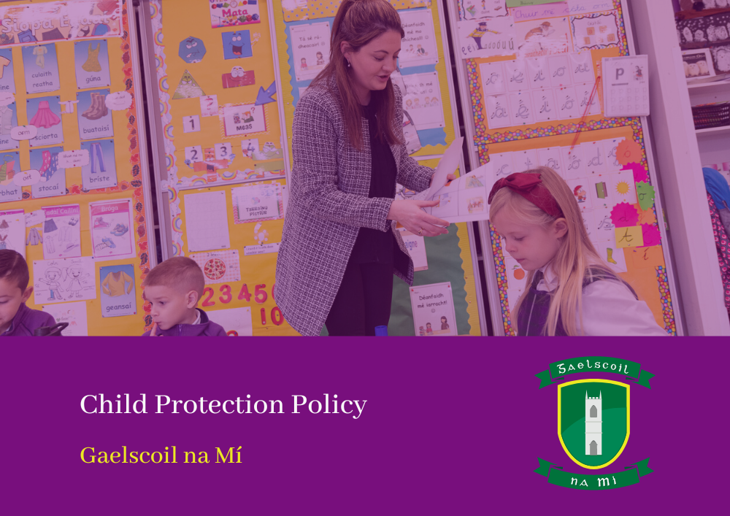

**Mandatory Template 1: Child Safeguarding Statement and Risk Assessment Template** 

**Child Safeguarding Statement- January 2022**

Gaelscoil na Mí is a primary school providing primary education to pupils from Junior Infants to Sixth Class.

In accordance with the requirements of the [Children First Act 2015](http://www.irishstatutebook.ie/eli/2015/act/36/enacted/en/pdf), [Children First: National Guidance for the Protection and Welfare of Children 2017](https://assets.gov.ie/25844/b90aafa55804462f84d05f87f0ca2bf6.pdf), [the Addendum to Children First (2019)](https://assets.gov.ie/25819/c9744b64dfd6447985eeffa5c0d71bbb.pdf), the [Child Protection Procedures for Primary and Post Primary Schools 2017](https://www.gov.ie/pdf/?file=https://assets.gov.ie/45063/2d4b5b3d781e4ec1ab4f3e5d198717d9.pdf#page=1) and [Tusla Guidance on the preparation of Child Safeguarding Statements](https://www.tusla.ie/uploads/content/4214-TUSLA_Guidance_on_Developing_a_CSS_LR.PDF), the Board of Management of Gaelscoil na Mí has agreed the Child Safeguarding Statement set out in this document.

1. The Board of Management has adopted and will implement fully and without modification the Department’s Child Protection Procedures for Primary and Post Primary Schools 2017 as part of this overall Child Safeguarding Statement
2. The Designated Liaison Person (DLP) is Clár Ní Mhaoláin - Príomhoide
3. The Deputy Designated Liaison Person (Deputy DLP) is Fionnuala Nic Cába - Leasphríomhoide
4. The Board of Management recognises that child protection and welfare considerations permeate all aspects of school life and must be reflected in all of the school’s policies, procedures, practices and activities. In its policies, procedures, practices and activities, the school will adhere to the following principles of best practice in child protection and welfare:

The school will:

* recognise that the protection and welfare of children is of paramount importance, regardless of all other considerations;
* fully comply with its statutory obligations under the Children First Act 2015 and other relevant legislation relating to the protection and welfare of children;
* fully co-operate with the relevant statutory authorities in relation to child protection and welfare matters;
* adopt safe practices to minimise the possibility of harm or accidents happening to children and protect workers from the necessity to take unnecessary risks that may leave themselves open to accusations of abuse or neglect;
* develop a practice of openness with parents and encourage parental involvement in the education of their children; and
* fully respect confidentiality requirements in dealing with child protection matters.

The school will also adhere to the above principles in relation to any adult pupil with a special vulnerability.

1. The following procedures/measures are in place:

* In relation to any member of staff who is the subject of any investigation (howsoever described) in respect of any act, omission or circumstance in respect of a child attending the school, the school adheres to the relevant procedures set out in Chapter 7 of the Child Protection Procedures for Primary and Post-Primary Schools 2017 and to the relevant agreed disciplinary procedures for school staff which are published on the DE website.
* In relation to the selection or recruitment of staff and their suitability to work with children, the school adheres to the statutory vetting requirements of the [National Vetting Bureau (Children and Vulnerable Persons) Acts 2012 to 2016](https://revisedacts.lawreform.ie/eli/2012/act/47/revised/en/pdf) and to the wider duty of care guidance set out in relevant Garda vetting and recruitment circulars published by the Department of Education and available on the DE website.
* In relation to the provision of information and, where necessary, instruction and training, to staff in respect of the identification of the occurrence of harm (as defined in the 2015 Act) the school-
* Has provided each member of staff with a copy of the school’s Child Safeguarding Statement
* Ensures all new staff are provided with a copy of the school’s Child Safeguarding Statement
* Encourages staff to avail of relevant training
* Encourages Board of Management members to avail of relevant training
* The Board of Management maintains records of all staff and Board member training
* In relation to reporting of child protection concerns to Tusla, all school personnel are required to adhere to the procedures set out in the Child Protection Procedures for Primary and Post-Primary Schools 2017, including in the case of registered teachers, those in relation to mandated reporting under the Children First Act 2015.
* In this school the Board has appointed the abovenamed DLP as the “relevant person” (as defined in the Children First Act 2015) to be the first point of contact in respect of the schools child safeguarding statement.
* All registered teachers employed by the school are mandated persons under the Children First Act 2015.
* In accordance with the Children First Act 2015 and the Addendum to Children First (2019), the Board has carried out an assessment of any potential for harm to a child while attending the school or participating in school activities. A written assessment setting out the areas of risk identified and the school’s procedures for managing those risks is included with the Child Safeguarding Statement.
* The various procedures referred to in this Statement can be accessed via the school’s website, the DE website or will be made available on request by the school.

**Note:** The above is not intended as an exhaustive list. Individual Boards of Management shall also include in this section such other procedures/measures that are of relevance to the school in question.

1. This statement has been published on the school’s website and has been provided to all members of school personnel, the Parents’ Association (if any) and the patron. It is readily accessible to parents and guardians on request. A copy of this Statement will be made available to Tusla and the Department if requested.
2. This Child Safeguarding Statement will be reviewed annually or as soon as practicable after there has been a material change in any matter to which this statement refers.

This Child Safeguarding Statement was adopted by the Board of Management on 26/01/22.

This Child Safeguarding Statement was reviewed by the Board of Management on 16.05.23.

**SÍNITHE**

Cormac Mc Cashin Clár Ní Mhaoláin

__________________________ __________________________

*Cathaoirleach Príomhoide*

**Dáta: 16.05.23**

**Child Safeguarding Risk Assessment- January 2022** 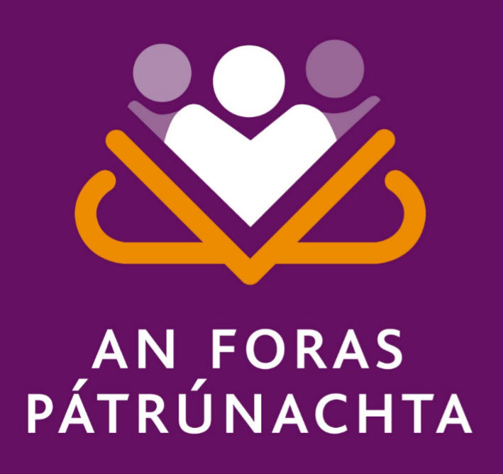

**Written Assessment of Risk of Gaelscoil na Mí**

In accordance with section 11 of the Children First Act 2015 and with the requirement of Chapter 8 of the *Child Protection Procedures for Primary and Post-Primary Schools 2017*, the following is the Written Risk Assessment of Gaelscoil na Mí.

|  |  |  |
| --- | --- | --- |
| 1. **List of school activities** | 1. **The school has identified the following risk of harm in respect of its activities –** | 1. **The school has the following procedures in place to address the risks of harm identified in this assessment -** |
| (insert list of school activities in this section)   1. Assembly arrangements at start of school day 2. Dismissal arrangements at end of school day 3. Arrival and exit arrangements during school day 4. Arrangements for Covid19 5. Children’s break 6. Use of electronic devices 7. Visitors to School 8. Individual support and teaching 9. Use of toilets in school 10. School trips 11. First Aid and Medicine Care 12. Challenging behaviour 13. Teaching resources and aids 14. Curricular provision in respect of SPHE, RSE, Stay Safe | (insert risks of harm identified in this section)  Children walking to entrances at the correct time  Other adults on school premises  Freezing weather and snow days  Children leaving the school building  Children walking home on their own  Children who are collected  Child arriving  Child leaving  In conjunction with the school’s Covid19 Action Plan, available from Conor Mac an tSaoir (Covid Officer), Rang 6B  Isolation Room  Supervision of child during their stay in Isolation room  In class supervision (Rainy days)  Supervision on yard  Travelling to and from yard  Accidents/ Exceptional activities/ Behavioural activities  Accidents on the yard- To the head  Accidents of the yard- Other body parts  See “Acceptable Usage Policy”  Staff mobile phones  Pupil mobile phones  Tablets/ Laptops  Visitors who are working on the building and/ or in classes  Visiting Teachers (Music, Dance, Drama etc)  That harm would come to the child whilst on their own  Breaktime (Outside)  Class time  Adequate supervision  Exact, up to date information made available to staff  Correct medication for the correct child  School trips  Please see Code of Behaviour  The child who engages in challenging behaviour and other children present  Adequate supervision of pupils in store rooms  Inclusivity of resources  All aspects of SPHE and RSE will be taught | (insert the procedures in place to address risks of harm in this section)  Principal and Special Education teachers on duty at both gates from 8.40am  Adults to travel in a one way system around the school building, parents/ guardians to remain outside school premises at beginning of school day  The school caretaker clears the main routes of snow and spreads salt/ grit on main routes around school  Class teachers go at the top of the class line and the class walks after them to the school yard  Parents/ Guardians must send an email or note to the school to give their permission for their child/ren to walk home by themselves  The class teacher waits on the yard and each pupil will raise their hand to let the teacher know when their parent/ guardian/ minder has arrived to collect them  The parent/ guardian will leave the child at the school reception and the school secretary will let the child into the building. The parent/ guardian will sign the in/ out book.  Parent/ Guardian will come to the school office and the secretary will contact the class teacher. Class teacher will send the child to the office. Parent/ Guardian will sign the in/ out book.  In conjunction with the school’s Covid19 Action Plan, available from Conor Mac an tSaoir (Covid Officer), Rang 6B  Situated beside the principal’s office, opposite Rang 6B, door is left open and all necessary equipment is available to care for a child with suspected Covid  The class teacher stays with the child for the duration of their time in the isolation room. Principal is notified so they may make arrangements for class supervision.  Small break- Teachers are on duty between two classes and they walk between the classes supervising the pupils  Big break- Class teachers stay with their classes whilst eating, they then walk to the yard with their class and teachers on duty supervise yard time  Four teachers are on yard duty each break along with the Special Needs assistants. Every member of staff wears a high-vis jacket so they are quickly and easily identified  Children walk to the yard in quiet lines and on the first bell they immediately stop play and on the second bell they walk to their lines to go inside the school building  Every teacher has a yard book and they fill out yard records in this book. Reports are available in the staff room should a written report be necessary for the principal.  Every child with a head injury is taken to their class teacher (or class teacher is sent for, depending on the circumstances). It is the class teacher who will call parent/ guardian and it is the teacher on the yard who will fill in a written report for the principal.  Staff have received first aid training. The child’s class teacher will always be informed of injury and the teacher on yard and the class teacher will come to an agreement over the course of treatment for the child and their injury.  See “Acceptable Usage Policy”  Staff are not permitted to use their phones during teaching time. If a staff member is waiting for an urgent call they must make the principal aware of this and cover can be arranged for their class for that time  Pupils’ mobile phones must be completely turned off- not just on silent, but powered off, from the start to the end of the school day and anywhere and everywhere on school premises.  If pupils do not follow these instructions their phone will be left in the principal’s office where a parent/ guardian must make arrangements to collect the phone  Tablets and laptops are only used under the supervision of staff members and the AUP is accepted in it’s entirety by pupils and parents alike  Every effort will be made to ensure any building/ remediation work is carried out before or after the school day. If this is not possible, visitors will proceed to the school office, they will sign the visitor’s book and contact tracing book and the principal and/ or caretaker will meet them there. The principal/ caretaker will accompany them to the work site. Visitors will report back to the school office when work is complete and sign out.  Prior to any visiting teacher coming to the school they will provide all associated vetting documents to the principal. Visitors will wait in the school reception until the class teacher/ principal meets them and accompanies them to the correct classroom.  The visiting teacher will sign the visitor book/ Contact tracing book. The class teacher will remain with the visiting teacher at all times.  The visiting teacher will return to the school office with the class teacher/ principal at the end of their session to sign out.  If a child is working independently (outside of their classroom) with their class teacher, Special Education teacher or Special Needs Assistant, the work must take place in an open, accessible area and other members of staff must be able to access the area and the work must be integral to the child’s learning plan.  Every child will use the large toilet opposite the “Seomra Órga” if they must use the toilet at break time ie if not going to the toilet will cause a toileting accident. Pupils seek permission from the teacher on yard, they go in pairs, one waits outside the toilet whilst the other goes and they inform the teacher on yard when they are back on yard.  Each classroom has two toilets. Boys and girls toilets are not distinguished in Infant classes. Each teacher will have their own toilet system and this will be made very clear to pupils through practice and repetition. Only one child is allowed to use the toilet at any one time. In the event that a child has a toileting accident where a change of clothes is necessary, pupils must change their own clothes. If the child has difficulty in doing so parents/ guardians will be contacted. Should a pupil have specific toileting needs this will be indicated on their individual plan and Special Needs Assistants and relevant teaching staff will be briefed on the child’s specific needs.  Covid has impinged on our school trips and excursions but each class can still avail of walks in the local environment and around the village.  If a teacher wishes to take a class on a local outing they must speak to the principal and arrangements will be made for adequate supervision based on the duration of the trip, how many children will be present, class level, location of trip and perceived risks ie how many road crossings will the trip involve  At the beginning of each school year, it is the responsibility of parents to fill in a yellow form if their child has allergies or requires medication. These forms are collected and arranged in a folder which is made available to each staff member. Staff members must sign a form to indicate that they have read the allergies/ medical information.  Parents/ Guardians are asked to send their child’s medicine to school in a bag or box clearly labelled with the child’s name, class and attach a clear list of instructions or information page on how to administer the medicine. All medication will be kept in the secure medicine cupboard in the isolation room.  It is the responsibility of the class teacher to take any medication for children in their class on school trips.  It is the responsibility of the teacher co-ordinating excursions to football, rugby, dance, chess tournaments to take medication for any children attending such trips. All medication is to be returned by teachers following school trips/ occasions.  Please see Code of Behaviour  Each class has a CAT (Help required) card and when a teacher requires extra support for a pupil who engages in challenging behaviour the CAT card must be sent to the Principal or in the case she is unavailable, a member of the SET team, teacher next door, teachers with posts of responsibility.  Attempts will be made to deescalate the situation in the classroom but if this is not possible and there is a risk that other children will be hurt, the class will be taken to the library, the school hall, the yard.  School staff are to remain at a distance from the child demonstrating challenging behaviour unless there is a risk that the child will hurt themselves.  If a child has a behaviour plan with targets relating to challenging behaviour, that plan and targets will be followed.  Pupils are not allowed to enter store rooms unsupervised and staff are not permitted to allow pupils to retrieve items from any of the store rooms.  Teachers and SNAs must collect all necessary resources and aids prior to their lessons  Gaelscoil na Mí is a multi-denominational, co-educational primary school and as such teachers and SNAs must make every effort to reflect the inclusivity of our school environment and indeed the wider community. Consideration must be given to adequate representation of the following groups;  Pupils from ethnic minorities/migrants  Members of the Traveller community  Lesbian, gay, bisexual or transgender (LGBT) children  Pupils of minority religious faiths  Children in care  Children on CPNS (Child Protection Notification System)  Children with medical needs  We operate a two year SPHE cycle and RSE is included each year in the second school term.  The principal will note correct tuition of the SPHE and RSE curriculum through the cuntas míosúl.  Parents will be informed when RSE lessons are to take place and will be asked to contact the class teacher/ principal should they wish to withdraw their child. |

|  |
| --- |
| **Important Note:** It should be noted that risk in the context of this risk assessment is the risk of “harm” as defined in the Children First Act 2015 and not general health and safety risk. The definition of harm is set out in Chapter 4 of the *Child Protection Procedures for Primary and Post- Primary*  *Schools 2017* |

In undertaking this risk assessment, the board of management has endeavoured to identify as far as possible the risks of harm that are relevant to this school and to ensure that adequate procedures are in place to manage all risks identified. While it is not possible to foresee and remove all risk of harm, the school has in place the procedures listed in this risk assessment to manage and reduce risk to the greatest possible extent.

**Examples of activities, risks and procedures**

The examples listed in this document are provided to assist schools in undertaking their risk assessment under the Children First Act, 2015. Schools should note that this list of examples is not intended to be exhaustive. It is the responsibility of each school to ensure, as far as possible, that any other risks and procedures that are relevant to its own particular circumstances are identified and specified in the written risk assessment and that adequate procedures are in place to address all risks identified.

It is acknowledged that schools already have in place a range of policies, practices and procedures to mitigate the risk of harm to children while they are participating in the activities of the school and that some school activities will carry low or minimal risks of harm compared to others. In the context of the risk assessment that must be undertaken by schools, the Children First Act, 2015 refers to risk as “any potential for harm”. Therefore, it is important that, as part of its risk assessment process, each school lists and reviews all of its various activities (which shall include identifying those that may carry low risk of harm as well as those that carry higher risks of harm). Doing so will help the school to (1) identify, as required under the Children First Act, 2015, any risks of harm that may exist in respect of the school’s activities, (2) identify and assess the adequacy of the various procedures already in place to manage those risks of harm and (3) identify and put in place any such additional procedures as are considered necessary to manage any risk identified.

The Addendum to Children First: National Guidance for the Protection and Welfare of Children published in January 2019 clarifies that organisations providing relevant services to children should consider the specific issue of online safety when carrying out their risk assessment and preparing their Child Safeguarding Statement.

The Guidance on Continuity of Schooling for primary and post-primary schools (April 2020) advises of the importance of teachers maintaining the safe and ethical use of the internet during distance learning and assisting parents and guardians to be aware of their role also. Schools should ensure that their Acceptable Use Policy (AUP) informs and guides remote or distance learning activity.

Important Note: It should be noted that risk in the context of this risk assessment is the risk of “harm” as defined in the Children First Act, 2015 and not general health and safety risk. The definition of harm is set out in chapter 4 of the Child Protection Procedures for Primary and Post-Primary Schools 2017.

**Examples of School Activities**

* Daily arrival and dismissal of pupils
* Recreation breaks for pupils
* Classroom teaching
* One-to-one teaching
* One-to one learning support
* One-to-one counselling
* Outdoor teaching activities
* Online teaching and learning remotely
* Sporting Activities
* School outings
* School trips involving overnight stay
* School trips involving foreign travel
* Use of toilet/changing/shower areas in schools
* Provision of residential facilities for boarders
* Annual Sports Day
* Fundraising events involving pupils
* Use of off-site facilities for school activities
* School transport arrangements including use of bus escorts
* Care of children with special educational needs, including intimate care where needed,
* Care of any vulnerable adult students, including intimate care where needed
* Management of challenging behaviour amongst pupils, including appropriate use of restraint where required
* Management of provision of food and drink
* Administration of Medicine
* Administration of First Aid
* Curricular provision in respect of SPHE, RSE, Stay Safe
* Prevention and dealing with bullying amongst pupils
* Training of school personnel in child protection matters
* Use of external personnel to supplement curriculum
* Use of external personnel to support sports and other extra-curricular activities
* Care of pupils with specific vulnerabilities/ needs such as
* Pupils from ethnic minorities/migrants
* Members of the Traveller community
* Lesbian, gay, bisexual or transgender (LGBT) children
* Pupils perceived to be LGBT
* Pupils of minority religious faiths
* Children in care
* Children on CPNS
* Children with medical needs
* Recruitment of school personnel including -
* Teachers/SNA’s
* Caretaker/Secretary/Cleaners
* Sports coaches
* External Tutors/Guest Speakers
* Volunteers/Parents in school activities
* Visitors/contractors present in school during school hours
* Visitors/contractors present during after school activities
* Participation by pupils in religious ceremonies/religious instruction external to the school
* Use of Information and Communication Technology by pupils in school, including social media
* Application of sanctions under the school’s Code of Behaviour including detention of pupils, confiscation of phones etc.
* Students participating in work experience in the school
* Students from the school participating in work experience elsewhere
* Student teachers undertaking training placement in school
* Use of video/photography/other media to record school events
* After school use of school premises by other organisations
* Use of school premises by other organisation during school day
* Breakfast club
* Homework club/evening study

**Examples of Risks of Harm**

* Risk of harm not being recognised by school personnel
* Risk of harm not being reported properly and promptly by school personnel
* Risk of child being harmed in the school by a member of school personnel
* Risk of child being harmed in the school by another child
* Risk of child being harmed in the school by volunteer or visitor to the school
* Risk of child being harmed by a member of school personnel, a member of staff of another organisation or other person while child participating in out of school activities e.g. school trip, swimming lessons
* Risk of harm due to inappropriate use of online remote teaching and learning communication platform such as an uninvited person accessing the lesson link, students being left unsupervised for long periods of time in breakout rooms
* Risk of harm due to bullying of child
* Risk of harm due to racism
* Risk of harm due to inadequate supervision of children in school
* Risk of harm due to inadequate supervision of children while attending out of school activities
* Risk of harm due to inappropriate relationship/communications between child and another child or adult
* Risk of harm due to children inappropriately accessing/using computers, social media, phones and other devices while at school
* Risk of harm to children with SEN who have particular vulnerabilities, including medical vulnerabilities
* Risk of harm to child while a child is receiving intimate care
* Risk of harm due to inadequate code of behaviour
* Risk of harm in one-to-one teaching, counselling, coaching situation
* Risk of harm caused by member of school personnel communicating with pupils in an inappropriate manner via social media, texting, digital device or other manner
* Risk of harm caused by member of school personnel accessing/circulating inappropriate material via social media, texting, digital device or other manner

**Examples of Procedures to address risks of harm**

* All school personnel are provided with a copy of the school’s *Child Safeguarding Statement*
* The *Child Protection Procedures for Primary and Post-Primary Schools 2017* are made available to all school personnel
* School Personnel are required to adhere to the *Child Protection Procedures for Primary and Post-Primary Schools 2017* and all registered teaching staff are required to adhere to the *Children First Act 2015* and it’s Addendum (2019)
* The school implements in full the Stay Safe Programme
* The school implements in full the SPHE curriculum
* The school implements in full the Wellbeing Programme at Junior Cycle
* The school has an Anti-Bullying Policy which fully adheres to the requirements of the Department’s *Anti-Bullying Procedures for Primary and Post-Primary Schools*
* The school undertakes anti-racism awareness initiatives
* The school has a yard/playground supervision policy to ensure appropriate supervision of children during, assembly, dismissal and breaks and in respect of specific areas such as toilets, changing rooms etc.
* The school has in place a policy and clear procedures in respect of school outings
* The school has a Health and safety policy
* The school adheres to the requirements of the Garda vetting legislation and relevant DE circulars in relation to recruitment and Garda vetting
* The school has a codes of conduct for school personnel (teaching and non-teaching staff)
* The school complies with the agreed disciplinary procedures for teaching staff
* The school has a Special Educational Needs policy
* The school has an intimate care policy/plan in respect of students who require such care
* The school has in place a policy and procedures for the administration of medication to pupils
* The school –
  + - Has provided each member of school staff with a copy of the school’s Child Safeguarding Statement
    - Ensures all new staff are provided with a copy of the school’s Child Safeguarding Statement
    - Encourages staff to avail of relevant training
    - Encourages board of management members to avail of relevant training
    - Maintains records of all staff and board member training
* The school has in place a policy and procedures for the administration of First Aid
* The school has in place a code of behaviour for pupils
* The school has an Acceptable Use Policy in place, to include provision for online teaching and learning remotely, and has communicated this policy to parents
* The school has in place a policy governing the use of smart phones and tables devices in the school by pupils as per circular 38/2018
* The school has in place a Critical Incident Management Plan
* The school has in place a Home School Liaison policy and related procedures
* The school has in place a policy and procedures for the use of external persons to supplement delivery of the curriculum
* The school has in place a policy and procedures for the use of external sports coaches
* The school has in place a policy and clear procedures for one-to-one teaching activities
* The school has in place a policy and procedures for one-to-one counselling
* The school has in place a policy and procedures in respect of student teacher placements
* The school has in place a policy and procedures in respect of students undertaking work experience in the school
* The school has in place a policy and procedures in respect of pupils of the school undertaking work experience in external organisations