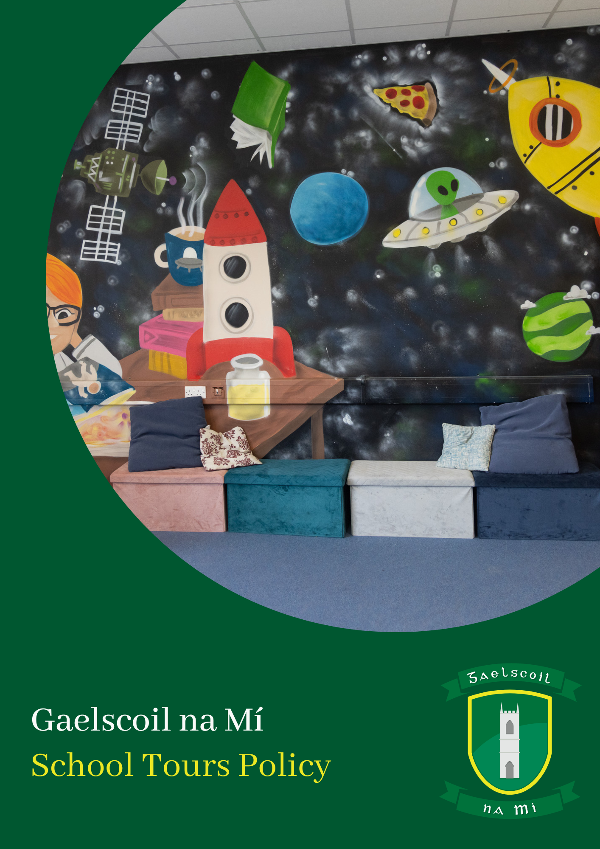

**School Tours Policy**

**Introduction**

The following policy has been formulated by the staff and Board of Management of Gaelscoil na Mí.

Taking into account the age and interests of the children and the curriculum being covered, school tours will be arranged by the school to present the children with a new environment in which they can observe, investigate, learn and socialise.

**Tours will be arranged at the discretion of the class teacher.**

**Rationale**

The need for this policy arises due to children being exposed to a wide variety of different experiences while on school outings, and the necessity to have a framework for good practice in place to cover all eventualities.

**Aims**

* To provide an enjoyable educational experience for all children
* To ensure all practical possibilities are covered in reducing the exposure of children to risk on outings

**Categories of trips**

For the purpose of this policy and recognising different requirements for different tours, the school has categorised trips into the following:

* **Category A:** This category relates to local trips only e.g. on-campus field trip, schools on campus, Donaghmore-Ashbourne GAA club for whole-class training, local playground, Garden City etc. These trips do not require transport, will be during school hours only and have no cost. Parents will be informed by the class teacher or school secretary via Aladdin and Newsletter. Permission slips will not be sought for this category.
* **Category B:** Trips in this category may or may not include a cost, a requirement for transport and may involve a whole class group or a group of students e.g. school sports team. Examples of trips in this category include swimming, GAA blitz (school team, not whole class event), events that support the school ethos, attending events in other schools such as dramas, quizzes and chess tournaments.Parents will be informed by the class teacher or school secretary via Aladdin (newsletter and message). Due to the varied nature of events in this category, a risk assessment will be completed for all trips in this category in line with the School Safeguarding Statement. Where a ‘medium-level’ or ‘high-level’ risk is identified, permission slips will be sought by the class teacher from each family.
* **Category C:** These whole-class trips involve a cost to families and transport will be needed. Examples of this category include trips involving travelling outside of normal school hours, trips to the Gaeltacht, trips to large venues (e.g. Zoo, Emerald Park) and trips to venues without coach parking adjacent to venue (e.g. The Gaeity). Parents will be informed by the class teacher or school secretary via Aladdin and a permission slip will need to be signed via letter sent to each home.

**Fieldtrips**

Fieldtrips are a separate category of trip which relate to a particular curricular area are encouraged. These trips can range from simple walks around the school campus to organised trips to relevant places of interest.

* The principal (or most senior member of staff present) must be informed in advance if it is proposed that a class leave the school grounds.
* Teachers are encouraged to plan and prepare children in advance of the trip and to carry out some follow up work in the classroom following the fieldtrip.
* Teachers should ensure adequate supervision at all times. Where necessary, an SNA or parent / guardian should accompany the class on the trip.
* Children should be appropriately dressed for the fieldtrip e.g. rain gear, suitable footwear etc.
* No child will be refused participation in any proposed activity because of family inability to pay.
* Buses booked for fieldtrips must be fitted with individual seatbelts and these should be worn by all children.

**Ensuring Safety, Managing Risk**

The risk involved with a school trip will be assessed within the context of the school Child Safeguarding Statement. The class teacher will seek advice from the Deputy Principal in relation to risk/risk assessment for a trip, tour or field work. Appropriate measures will be put in place to ensure student safety at all times.

**Supervision**

Supervision of students will be provided by the class teacher(s), other school staff (SNA, Special Education Teacher, Príomhoide, Secretary etc.) and by parents who have successfully completed Gardaí vetting.

* Children must obey their supervisors at all times
* Children must remain seated while travelling
* Children must remain with their allocated grouping and supervisor at all times
* Children will line up in their individual groups on disembarking from the bus/other
* Roll calls/head counts are taken when children return to the bus after each segment of the tour
* Eating is discouraged while travelling

**Success Criteria**

* Positive experiences for all
* Children having a safe enjoyable experience
* Teacher/Parent Satisfaction

**Not taking part**

If for any reason a student will not be taking part in any tour or fieldtrip, the school will make other arrangements for that student for the duration of that tour/fieldtrip. It is the responsibility of parents to let the class teacher know directly ahead of time and they will make the necessary arrangements. The school will give advance notice to parents via Aladdin and/or Newsletter about upcoming trips or events.

**Spending money**

Teachers will inform parents prior to the trip whether spending money will be allowed.

**Weather Conditions**

Rain and head gear will be essential for all children and a change of clothes may be necessary, depending on the venue.

**Additional Needs**

Teachers will ensure that venues are suitable for pupils with additional needs.

**Uniform**

Students will wear their school uniform on all school tours unless directed otherwise.

**Reports**

Where problems arise teachers will complete reports and communicate with the school principal within 24 hours of the incident. Teachers will also notify the relevant parents/guardians.

**Conduct on Tours**

Pupils’ behaviour on tours will comply with the standard set down in the School's Code of Behaviour. Where it is felt that a child's conduct would pose a safety risk or inhibit the educational benefit for self or others, the teacher may refuse the child permission to travel. Parents will be advised of this in advance.

**Further Info / Other Policies**

This policy is not a stand alone document. Further detail on school procedures applicable to School Tours can be read in our Code of Behaviour, Child Protection, Anti-Bullying and Acceptable Usage policies.

**Safety and Supervision**

Teachers will be extra vigilant when taking children out of the school. Special attention will be paid to - Road Safety, Behaviour on bus, Risks posed at particular venues (e.g. adventure playgrounds etc.).

**Informing Parents**

Teachers will ensure that Parents are given sufficient notice of the trip, cost (if applicable) and details.

**Implementation and review**

This policy was ratified in 2023 and implemented immediately. This policy will be reviewed by the Board of Management, teaching staff and parents every three years or as is necessary.

**Cathaoirleach:** Cormac Mc Cashin **Príomhoide:** Clár Ní Mhaoláin

Dáta: 26/04/23

**Appendix 1: TOUR CHECKLIST**

**Before the tour**

* Venue and transport booked
* Individual parents informed of travelling embargo (if applicable)
* Timetable organised
* Parents informed by letter
  + itinerary
  + timetable
  + cost
  + lunch arrangements
  + clothing necessary

**Agreement on**

* Leader
* Spending money
* Acceptable behaviour on bus
* Extra supervisors

**Day of Tour**

Tour leader will ensure;

* Tour kits are available (First aid, bin bags, illness bags, wet wipes)
* Payment for venues
* Payment for bus
* Money for coffee etc.

**After Tour**

* Report back to office
* Send thank you cards to parents etc.