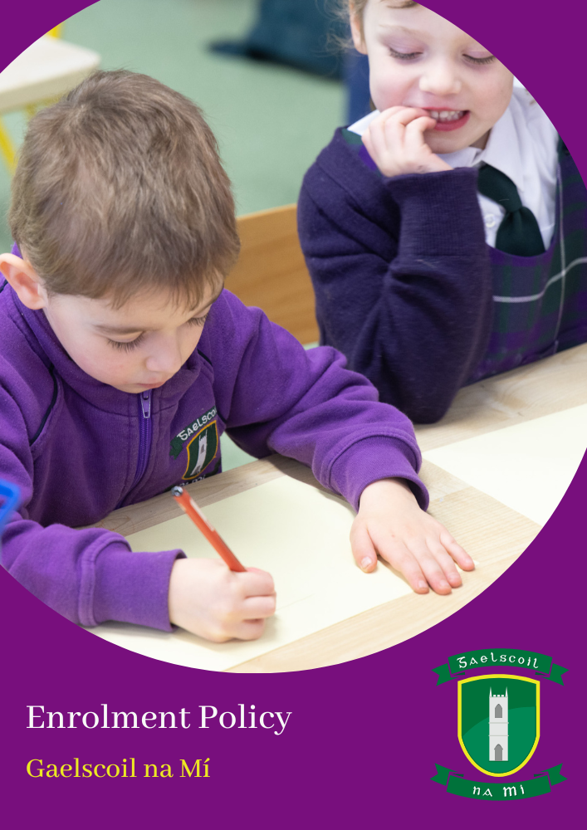

Admission Policy of Gaelscoil na Mí

School Address: Campas Oideachais Chill Dhéagláin, Cill Dhéagláin, Co. Na Mí

Roll number: 20382F

School Patron: An Foras Pátrúnachta

Introduction

This Admission Policy complies with the requirements of the Education Act 1998, the Education (Admission to Schools) Act 2018 and the Equal Status Act 2000. In drafting this policy, the board of management of the school has consulted with school staff, the school patron and with parents of children attending the school.

The policy was approved by the school patron on 30.11.23. It is published on the school’s website and will be made available in hardcopy, on request, to any person who requests it.

The relevant dates and timelines for Gaelscoil na Mí admission process are set out in the school’s annual admission notice which is published annually on the school’s website at least one week before the commencement of the admission process for the school year concerned.
This policy must be read in conjunction with the annual admission notice for the school year concerned.
The application form for admission is published on the school’s website and will be made available in hardcopy on request to any person who requests it.

The Irish language version of this policy will take precedence in the case of a discrepancy.

Characteristic spirit and general objectives of the school

Gaelscoil na Mí is an all-Irish primary school under An Foras Pátrúnachta.
It is a co-educational school established in 2011 and has a multi-denominational ethos.
The promotion of Irish is a primary objective of the school. We welcome all children regardless of their background, beliefs or special needs.

We are located in Ashbourne Education Campus in a modern, comfortable building. Our school community has grown steadily since first opening in 2011. As the biggest gaelscoil in Ashbourne, we take great pride and joy in promoting Irish culture in the wider community. We do this through celebrating our culture in sport, music, dance, art, drama and of course the Irish language.

Our school welcomes every child and family. We are proud of the positive atmosphere we have created in the school and for providing our students with a happy and holistic education.

Admission Statement

Gaelscoil na Mí will not discriminate in its admission of a student to the school on any of the following:

- the gender ground of the student or the applicant in respect of the student concerned,
- the civil status ground of the student or the applicant in respect of the student concerned,
- the family status ground of the student or the applicant in respect of the student concerned,
- the sexual orientation ground of the student or the applicant in respect of the student concerned,
- the religion ground of the student or the applicant in respect of the student concerned,
- the disability ground of the student or the applicant in respect of the student concerned,
- the ground of race of the student or the applicant in respect of the student concerned,
- the Traveller community ground of the student or the applicant in respect of the student concerned, or
- the ground that the student or the applicant in respect of the student concerned has special educational needs

As per section 61 (3) of the Education Act 1998, ‘civil status ground’, ‘disability ground’, ‘discriminate’, ‘family status ground’, ‘gender ground’, ‘ground of race’, ‘religion ground’, ‘sexual orientation ground’ and ‘Traveller community ground’ shall be construed in accordance with section 3 of the Equal Status Act 2000.

School with special education classes

Gaelscoil na Mí is a school which has established a class, with the approval of the Minister for Education, which provides an education exclusively for students with a category or categories of special educational needs specified by the Minister and may refuse to admit to the class a student who does not have the category of needs specified.

Gaelscoil na Mí will cooperate with the NCSE in the performance by the Council of its functions under the Education for Persons with Special Educational Needs Act 2004 in relation to the provision of education to children with special educational needs, including in particular by the provision and operation of a special class or classes when requested to do so by the Council.

Gaelscoil na Mí will comply with any direction served on the board or the patron under section 37A and 67(4)(b).

Categories of Special Educational Needs catered for in the school/special class

Gaelscoil na Mí with the approval of the Minister for Education and Skills, has established a class to provide an education exclusively for students with Autism Spectrum Disorder.

The relevant reports (which recommend that the child attend a special class) must be provided with the application for a school place.

In the event that the school is oversubscribed, the school will, when deciding on applications for admission, apply the following selection criteria in the order listed below to those applications that are received within the timeline for receipt of applications as set out in the school’s annual admission notice:

1. Current students of the school
2. Siblings* of existing school students
3. Siblings* of former school students
4. Children who have attained a determined level of fluency in Irish which would be
likely to decline if he/she is not admitted to an all-Irish school**
5. Children whose Irish language ability would allow the child to function and learn in class and where other students would not have to revert to English to communicate
6. According to age; oldest child first

*Brothers, sisters, half-siblings, foster or adopted siblings
**The onus will be on parents/guardians to provide sufficient evidence to demonstrate
to the board the required level of fluency in Irish. See further information in the relevant
document available from the school

Admission of Students

This school shall admit each student seeking admission except where –

- the school is oversubscribed (please see section 6 below for further details)

- a parent of a student, when required by the principal in accordance with section 23(4) of the Education (Welfare) Act 2000, fails to confirm in writing that the code of behaviour of the school is acceptable to him or her and that he or she shall make all reasonable efforts to ensure compliance with such code by the student

The special class attached to Gaelscoil na Mí provides an education exclusively for students with Autism Spectrum Disorder and the school may refuse admission to this class, where the student concerned does not have the specified category of special educational needs provided for in this class.

Oversubscription

Admission Requirement: A child must have their 4th birthday on March 31st of the year they intend to start school. Any application for a child who will reach their 4th birthday between 1st April and the first day of the school year will be placed on the main waiting list in the event of over-demand & may be offered a place if a school place becomes available after criteria have been applied.

In the event that the school is oversubscribed, the school will, when deciding on applications for admission, apply the following selection criteria in the order listed below to those applications that are received within the timeline for receipt of applications as set out in the school’s annual admission notice:
- Siblings* of current pupils.

- Children who have attained a determined level of fluency in Irish which would be likely to decline if he / she is not admitted to an all-Irish school.**

- Children who have a sibling* who have previously attended the school.

- According to age; the oldest child first.

*Brother, sister, half-siblings, adopted siblings, foster siblings

** The onus will be on parents / guardians to provide sufficient evidence to demonstrate to the board the required level of fluency in Irish. See further information in the relevant document available from the school.

In the event that there are two or more students tied for a place or places in any of the selection criteria categories above (the number of applicants exceeds the number of remaining places), the following arrangements will apply:

The school Board reserves the right to set the maximum number of pupils in any given class. The maximum number of pupils to be admitted in Junior Infants shall be 48.
If two or more pupils are tied under criteria 1/2/3, priority will be set according to the next criterion on the list. If criterion 4 applies, the time of birth available on the birth certificate will be taken into account.

What will not be considered or taken into account

In accordance with section 62(7)(e) of the Education Act, the school will not consider or take into account any of the following in deciding on applications for admission or when placing a student on a waiting list for admission to the school:

Points (a) to (g) must be included here by all schools. There are limited exceptions to some of these (highlighted in red below) and schools must retain the exceptions that apply to them and delete those that do not:

- a student’s prior attendance at a pre-school or pre-school service, including naíonraí,

- the payment of fees or contributions (howsoever described) to the school;

- a student’s academic ability, skills or aptitude;
other than in relation to:
- admission to a special class insofar as it is necessary in order to ascertain whether or not the student has the category of special educational needs concerned and/or
- admission to an Irish language school, in accordance with the provisions of section 62(9) of the act

- the occupation, financial status, academic ability, skills or aptitude of a student’s parents;

- a requirement that a student, or his or her parents, attend an interview, open day or other meeting as a condition of admission;

- a student’s connection to the school by virtue of a member of his or her family attending or having previously attended the school;
other than in the case of the school wishing to include a selection criteria based on siblings of a student attending or having attended the school.

- the date and time on which an application for admission was received by the school,

This is subject to the application being received at any time during the period specified for receiving applications set out in the annual admission notice of the school for the school year concerned.
This is also subject to the school making offers based on existing waiting lists (up until 31st January 2025 only).

Decisions on applications

All decisions on applications for admission to Gaelscoil na Mí will be based on the following:
- Our school’s admission policy
- The school’s annual admission notice (where applicable)
- The information provided by the applicant in the school’s official application form received during the period specified in our annual admission notice for receiving applications

(Please see section 14 below in relation to applications received outside of the admissions period and section 15 below in relation to applications for places in years other than the intake group.)

Selection criteria that are not included in our school admission policy will not be used to make a decision on an application for a place in our school.

Notifying applicants of decisions

Applicants will be informed in writing as to the decision of the school, within the timeline outlined in the annual admissions notice.

If a student is not offered a place in our school, the reasons why they were not offered a place will be communicated in writing to the applicant, including, where applicable, details of the student’s ranking against the selection criteria and details of the student’s place on the waiting list for the school year concerned.

Applicants will be informed of the right to seek a review/right of appeal of the school’s decision (see section 18 below for further details).

Acceptance of an offer of a place by an applicant

In accepting an offer of admission from Gaelscoil na Mí, you must indicate—

(i) whether or not you have accepted an offer of admission for another school or schools. If you have accepted such an offer, you must also provide details of the offer or offers concerned and

(ii) whether or not you have applied for and awaiting confirmation of an offer of admission from another school or schools, and if so, you must provide details of the other school or schools concerned.

Circumstances in which offers may not be made or may be withdrawn

An offer of admission may not be made or may be withdrawn by Gaelscoil na Mí where—
- it is established that information contained in the application is false or misleading.
- an applicant fails to confirm acceptance of an offer of admission on or before the date set out in the annual admission notice of the school.
- the parent of a student, when required by the principal in accordance with section 23(4) of the Education (Welfare) Act 2000, fails to confirm in writing that the code of behaviour of the school is acceptable to him or her and that he or she shall make all reasonable efforts to ensure compliance with such code by the student; or
- an applicant has failed to comply with the requirements of ‘acceptance of an offer’ as set out in section 10 above.

Sharing of Data with other schools

Applicants should be aware that section 66(6) of the Education (Admission to Schools) Act 2018 allows for the sharing of certain information between schools in order to facilitate the efficient admission of students.

Section 66(6) allows a school to provide a patron or another board of management with a list of the students in relation to whom—

(i) an application for admission to the school has been received,

(ii) an offer of admission to the school has been made, or

(iii) an offer of admission to the school has been accepted.

The list may include any or all of the following:
(i) the date on which an application for admission was received by the school;

(ii) the date on which an offer of admission was made by the school;

(iii) the date on which an offer of admission was accepted by an applicant;

(iv) a student’s personal details including his or her name, address, date of birth and personal public service number (within the meaning of section 262 of the Social Welfare Consolidation Act 2005).

Waiting list in the event of oversubscription

In the event of there being more applications to the school year concerned than places available, a waiting list of students whose applications for admission to Gaelscoil na Mí were unsuccessful due to the school being oversubscribed will be compiled and will remain valid for the school year in which admission is being sought.

Placement on the waiting list of Gaelscoil na Mí is in the order of priority assigned to the students’ applications after the school has applied the selection criteria in accordance with this admission policy.

Offers of any subsequent places that become available for and during the school year in relation to which admission is being sought will be made to those students on the waiting list, in accordance with the order of priority in relation to which the students have been placed on the list.

The supplementary waiting list will be created if applications are received after the closing date set out in the Annual Admission Notice. Applications will be ranked according to the selection criteria in this admissions policy. The first waiting list will be cleared before candidates are offered places on this supplementary list.

Late Applications

A place will be offered if a place is available in the school.

If there is an over-subscription for places at the school following the main admissions process, any school place that subsequently emerges from the waiting list created from that process will be filled.

If applications are received after the closing date as set out in the Annual Admission Notice a supplementary waiting list will be created. The main waiting list will be cleared before candidates are offered places on this supplementary list. When a space becomes available in the school, applications for the supplementary waiting list will be considered against the selection criteria in this admissions policy on the day that that place becomes available in accordance with the School Admissions Act 2018 and in accordance with any regulations made under that Act.

Procedures for admission of students to other years and during the school year

The procedures of the school in relation to the admission of students who are not already admitted to the school to classes or years other than the school’s intake group are as follows:

Parents/guardians wishing to apply for a place in any class other than Junior Infants must write an application letter to this effect to the Chairperson of the Board. The decision to accept children in any other class is a matter for the Board of Management to decide.

Senior Infants / 1st Class
Places will be allocated if places are available in the following classes: Senior Infants and 1st Class. Where the number of applications exceeds the number of places available in the relevant class, the school will apply the selection criteria set out in Section 6 of this policy applies to such applications. Where no places are available, the child's name will be placed on the waiting list in accordance with Section 13 of this policy.

2nd to 6th Class
Children in 2nd to 6th class will be given a place if there is space in the class and the Principal / Board of Management decides that the child's Irish language ability is at a level that would allow the child to function and learn in class and wherer other pupils would not have to turn to English to communicate. The parent/guardian will be required to provide evidence of this standard. The Board of Management will have the final decision in these cases.

The procedures of the school in relation to the admission of students who are not already admitted to the school, after the commencement of the school year in which admission is sought, are as follows:

Parents / guardians wishing to apply for a place in any class other than Junior Infants must write an application letter to this effect to the Chairperson of the Board. The decision to accept children in any other class is a matter for the Board of Management to decide.

Senior Infants / 1st Class
Places will be allocated if places are available in the following classes: Senior Infants and 1st Class. Where the number of applications exceeds the number of places available in the relevant class, the school will apply the selection criteria set out in Section 6 of this policy applies to such applications. Where no places are available, the child's name will be placed on the waiting list in accordance with Section 13 of this policy.

2nd to 6th Class
Children in 2nd to 6th class will be given a place if there is space in the class and the Principal / Board of Management decides that the child's Irish language ability is at a level that would allow the child to function and learn in class and wherer other pupils would not have to turn to English to communicate. The parent / guardian will be required to provide evidence of this standard. The Board of Management will have the final decision in these cases.

Declaration in relation to the non-charging of fees

This rule applies to all schools.

The board of Gaelscoil na Mí or any persons acting on its behalf will not charge fees for or seek payment or contributions (howsoever described) as a condition of-
- an application for admission of a student to the school, or
- the admission or continued enrolment of a student in the school.

Arrangements regarding students not attending religious instruction

Our school welcomes all pupils. The school has a multi-denominational ethos and our school follows an ethical and spiritual program. Faith formation/Religious instruction is not part of the program and as such all students can attend such classes.

Reviews/appeals

Review of decisions by the board of Management
The parent of the student, or in the case of a student who has reached the age of 18 years, the student, may request the board to review a decision to refuse admission. Such requests must be made in accordance with Section 29C of the Education Act 1998.
The timeline within which such a review must be requested and the other requirements applicable to such reviews are set out in the procedures determined by the Minister under section 29B of the Education Act 1998 which are published on the website of the Department of Education and Skills.
The board will conduct such reviews in accordance with the requirements of the procedures determined under Section 29B and with section 29C of the Education Act 1998.
Note: Where an applicant has been refused admission due to the school being oversubscribed, the applicant must request a review of that decision by the board of management prior to making an appeal under section 29 of the Education Act 1998.
Where an applicant has been refused admission due to a reason other than the school being oversubscribed, the applicant may request a review of that decision by the board of management prior to making an appeal under section 29 of the Education Act 1998.

Right of appeal
Under Section 29 of the Education Act 1998, the parent of the student, or in the case of a student who has reached the age of 18 years, the student, may appeal a decision of this school to refuse admission.
An appeal may be made under Section 29 (1)(c)(i) of the Education Act 1998 where the refusal to admit was due to the school being oversubscribed.
An appeal may be made under Section 29 (1)(c)(ii) of the Education Act 1998 where the refusal to admit was due a reason other than the school being oversubscribed.
Where an applicant has been refused admission due to the school being oversubscribed, the applicant must request a review of that decision by the board of management prior to making an appeal under section 29 of the Education Act 1998. (see Review of decisions by the Board of Management)
Where an applicant has been refused admission due to a reason other than the school being oversubscribed, the applicant may request a review of that decision by the board of management prior to making an appeal under section 29 of the Education Act 1998. (see Review of decisions by the Board of Management)
Appeals under Section 29 of the Education Act 1998 will be considered and determined by an independent appeals committee appointed by the Minister for Education and Skills.
The timeline within which such an appeal must be made and the other requirements applicable to such appeals are set out in the procedures determined by the Minister under section 29B of the Education Act 1998 which are published on the website of the Department of Education and Skills.

