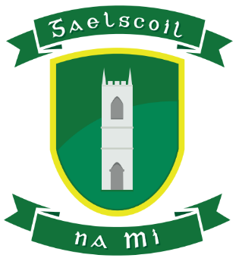
Foirm Chlárúcháin do Naíonáin Bheaga 2024-25
Registration form for Junior Infants 2024-25

Glacfar le foirmeacha ó 08.01.24 go 24.01.24
Forms will be accepted from 08.01.24 to 24.01.24

Sloinne an Pháiste:___________________ Céad Ainm(neacha) :_____________________
Surname of child First Name(s)

Seoladh: __________________________________________________________________
Address __________________________________________________________________
__________________________________________________________________

Dáta Breithe: ____/____/____
Date of Birth

Tuismitheoir/Caomhnóir 1: Ainm ______________________ Uimhir: __________________
Parent/Guardian 1: Name Number

Ríomhphost / Email: __________________________________________________________

Tuismitheoir/Caomhnóir 2: Ainm ______________________ Uimhir: __________________
Parent/Guardian 2: Name Number

Ríomhphost / Email: __________________________________________________________

Leathanach 1 as 2 / Page 1 of 2

1. An bhfuil siblín(í)* ag an bpáiste ag freastal ar an scoil faoi láthair? Má tá, cad is ainm dóibh?
1. Does the child have a sibling(s)*, currently attending the school? If so, what is their name?
___________________________________________________________________________

2. An bhfuil siblín(í)* ag an bpáiste atá ina (h)iar-dhalta scoile? Má tá, cad is ainm dóibh agus cén bhliain ar fhág siad an scoil?
2. Does the child have a sibling(s)* who is a past pupil of the school? If so, what is their name and what year did they leave the school?

3. An deimhin gur ghnóthaigh an dalta leibhéal líofachta sa Ghaeilge agus gur dhócha go rachadh an líofacht sin ar gcúl mura ligfí isteach i scoil lán-Ghaeilge é/í?**
3. Has the child developed a level of fluency in Irish which would be likely to decline if he / she is not admitted to an all-Irish school? **
___________________________________________________________________________
*Is ionann sin agus deartháir, deirfiúr, leath-shiblín, páiste altramaigh nó uchtaithe *That refers to a brother, sister, half-sibling, foster sibling or adopted sibling

**Beidh an dualgas iomlán ar thuismitheoirí/chaomhnóirí fianaise leordhóthanach a chur ar fáil chun leibhéal líofachta sa Ghaeilge a léiriú don bhord. Tá eolas breise sa cháipéis ábhartha atá ar fáil ón scoil.
The onus will be on parents / guardians to provide sufficient evidence to demonstrate to the board the child’s level of fluency in Irish. See further information in the relevant document available from the school.

Seol ar ríomhphost go / Return by email to: oifig@gaelscoilnami.ie

Míle buíochas

Leathanach 2 as 2 / Page 2 of 2

