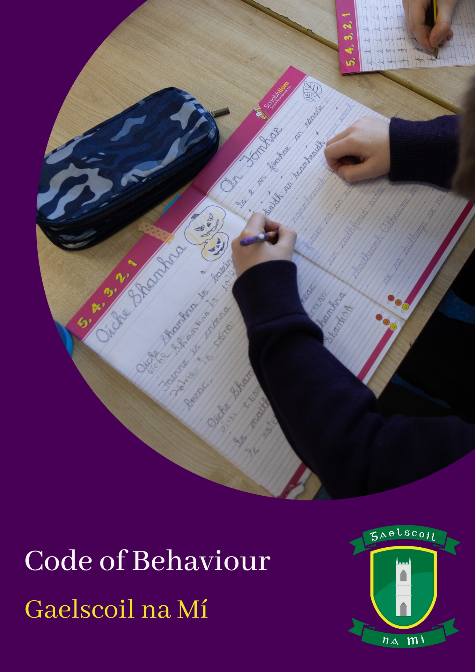
Opening Statement
This Code was updated during May 2026. Gaelscoil na Mí is a primary school catering for pupils from Junior Infants to 6th Class, with two Autism Classes, and there is a need for a satisfactory and effective Code of Behaviour for all pupils and staff members of the school.
In Gaelscoil na Mí, we aim to enable the school to function in an orderly manner so that children can make progress in all aspects of their development. The school promotes positive strategies to encourage good behaviour and to foster a positive and predictable learning environment.

Positive Behaviour and Reward Systems
- Each teacher will implement an appropriate and consistent reward system within their classroom to support and promote positive behaviour among the whole class, small groups and individual pupils.
- A range of rewards may be used to acknowledge positive behaviour and engagement. These may include: points, stamps, certificates, homework passes, visits to another classroom, and a visit to the principal’s office for recognition of exceptional work or behaviour (e.g. stickers or small prizes), positive communication with parents/guardians by sending positives notes home and/or awarding a green card (Cartaí Glasa).
- Positive Behaviour Awards may be presented in a manner appropriate to the context. This may be done privately, in the presence of the class, or at school assemblies.
- At weekly assemblies, a Green Balloon/Homework Pass is awarded to one pupil from each class in recognition of Gaeilgeoir na Seachtaine. A Purple Balloon is also awarded to any child who is celebrating their birthday during that week.
- Certificates are presented at assemblies on a weekly basis to pupils who consistently demonstrate adherence to school rules and expectations.
- At the end of each term, a formal awards presentation takes place during assembly. Each class teacher presents two awards, while the principal presents an additional award to recognise exceptional behaviour, notable improvement, consistency in behaviour, the achievement of behaviour targets, and dedicated effort in schoolwork.
- This system of recognition aims to promote a positive school climate by encouraging and affirming pupils’ efforts, achievements and personal development.

There are three principles that pupils follow at all times:
1.Green: We speak Irish at all times.
2.Dearg: Hands, feet and body to myself.
3.Corcra: We show respect and kindness to ourselves, to each other and to the school.
Responding to Behaviours of Concern
The behaviours and the corresponding responses are divided into three levels, and the details are set out in the tables below.
Behaviour of Concern  Level 1 |  | - Not making an effort to speak Irish (Junior Infants to 6th Class)  - Not listening in class and not following instructions from adults  - Disrupting class work  - Showing disrespect for the school environment  - Deliberately disturbing other pupils  - Not making their best effort with schoolwork/homework  - Messing or fooling around in class (including on wet days)  - Not showing respect and kindness
Response: Junior Infants to First Class
The Three-Step Bláthú System which is displayed in every classroom
Growing – Children may need reminders or support to achieve school expectations
Blooming – Children are participating positively in learning and school life, and are showing progress in their participation and wellbeing.
Flourishing – Children are demonstrating a high level of participation, responsibility, respect, and cooperation within the school community.
Response: Second Class to Sixth Class
5 Step System
- Verbal warning: Yellow Card sent home to be signed.
- Second verbal warning: Red Card sent home to be signed.
- Note in the homework journal/diary to be signed by the parent(s)/guardian(s).
- Time for reflection, and parent(s)/guardian(s) informed.
- Reflection Form to be completed at home with a parent/guardian and signed by the parent/guardian. During Golden Time on Friday, the class teacher will discuss the form with the pupil.
If the pattern of behaviour continues after the five steps, the behaviour will be treated as a Level 2 Behaviour and the corresponding responses will be applied.
Behaviour of Concern Level 2 | - Consistently not making an effort to speak Irish (1st to 6th Class)  - Damaging, defacing, or vandalising school property and resources, or the property and resources of other pupils  - Being disrespectful towards staff members and other pupils  - Showing disrespect towards teachers and staff members (e.g. rolling eyes, talking back, answering rudely, pulling faces)  - Taking part in rough play (wrestling, scuffling, kicking, pushing and shoving, play fighting)  - Being dishonest and telling lies  - Using smart devices* within the school building or on school premises, as well as other devices capable of recording images.
Response Approach
Time for reflection in a designated space in the classroom or on a chair/bench in the yard for the following length of time:  - Infants: 2 minutes  - 1st & 2nd Class: 4 minutes  - 3rd & 4th Class: 8 minutes  - 5th & 6th Class: 10 minutes  After the reflection time, the child will be asked the following three questions:  - Why did you need some space?  - What effect did this behaviour have on you and on the other person?  - What could you do differently next time? |  |  | - Spending time at the Reflection Table  - Spending half of break time at the Reflection Bench  - Visit to the principal’s office and completion of a Reflection Form with the principal, to be signed by the parent(s)/guardian(s)  - A letter sent home regarding the breach of school rules in the homework journal/diary, and a meeting between the teacher and the parent(s)/guardian(s) | - Parents/guardians will be informed in person or by telephone.  - A lesson will be taught to teach the relevant skill if a pattern of this behaviour is observed.  - If Level 2 behaviours occur repeatedly, the Stressors Tool from the Relate document will be used.  - If the behaviour does not improve, a meeting will be arranged involving the parent(s)/guardian(s), class teacher, and principal.  If the pattern of behaviour continues, the behaviour will be treated as a Level 3 Behaviour with the corresponding responses  *Electronic devices will be confiscated, and the parent/guardian will collect them from the Principal’s office.
Behaviour of Concern Level 3 | - Persistent refusal to speak Irish despite all efforts and responses/sanctions applied at Levels 1 and 2.  - Aggressive, threatening, or violent behaviour.  - Putting themselves or another person at risk of harm.  - Graffiti on school property.  - Bringing a weapon to school.  - Using, possessing, or being under the influence of alcohol, cigarettes, illegal drugs, or other harmful substances (including vapes).  - Deliberately injuring another person.  - Damaging school property.  - Leaving the school during the school day without permission.  - Using bad language or inappropriate language.  - Stealing.  - Making discriminatory or offensive remarks about other members of the school community on the basis of gender, ethnic or racial origin, belief or religion, age, disability, sexual orientation, language, or family circumstances.
Response
- Loss of privilege of going on school tours, trips, participating in workshops, school events, and sporting activities or representing the school
- In-school suspension
- Suspension*
- Expulsion*
*See Appendix 1

Managing aggressive or violent behaviour

The needs of children with ongoing or emerging behavioural, emotional and/or social difficulties, or those whose behaviour is aggressive, violent, or disruptive, will be discussed with the school psychologist. The school staff will engage with, or recommend referral to, other appropriate services such as the NCSE, NEPS, CDNT, Enable Ireland, etc.
In cases where a child displays behaviour that is highly violent or threatening (including children who leave the school premises), or where a child poses a risk to the safety of another child/children and/or staff members, their parents/guardians will be contacted and asked to come to the school immediately.

In cases where behavioural targets form part of a pupil’s Student Support Plan (SSP), the school will use these targets when responding to behaviours of concern. If the pattern of behaviour continues, the Code of Behaviour may also be applied.

School staff will use the Stressors Tool and the Continuum of Support outlined in the RELATE document to address behaviours of concern.

This Code of Behaviour may be used, where appropriate, in responding to incidents of bullying as set out in the school’s Be Cineálta Policy, and in matters relating to the school’s Acceptable Usage Policy.

This policy will be implemented by all teachers in the school. Parents/guardians will be asked to accept this policy at the beginning of each school year.

Implementation Date, Ratification and Review Timeline

The Board of Management ratified this policy, and it will come into effect from the beginning of the 2026/27 school year.

Siniú an Phríomhoide: | 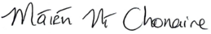 | Dáta: | 16/06/26
Siniú an Chathaoirligh: | 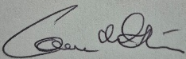 | Dáta: | 16/06/26

Appendix 1

(i) Suspension; Implementation, Opportunity to Respond, Appeals

Suspension is to be used as a proportionate response to the behaviour that is causing concern. The decision to suspend a student requires serious grounds such as;
- The student’s behaviour has had a seriously detrimental effect on the education of other students
- The student’s continued presence in the school currently constitutes a threat to safety
- The student is responsible for serious damage to property
Suspension can provide respite for staff and the student, give the student time to reflect on the link between their action/ behaviour and the consequences of such and give staff time to plan ways of helping the student to change their unacceptable behaviour. Suspension is described in further detail in chapters 10 and 11 of, “Developing a Code of Behaviour: Guidelines for Schools,” National Education Welfare Board, 2008.
Implementation
The BOM and Principal have a duty to ensure that there are no undue delays in an investigation into serious misbehaviour and in making decisions about the imposition of suspension or expulsion.
Where a preliminary assessment of the facts confirms serious misbehaviour has occurred that could warrant suspension, the principal will inform the pupil and their parents about the incident and also give them an opportunity to respond.
The Board of Management authorises the Principal to impose a suspension of up to three school days, where deemed appropriate, without requiring prior approval from the Board.

The Principal will notify the parents and the student in writing of the decision to suspend. The letter will confirm:

- the period of the suspension and the dates on which the suspension will begin and end
- the reasons for the suspension
- any study programme to be followed
- the arrangements for returning to school, including any commitments to be entered into by the student and the parents (for example, parents might be asked to reaffirm their commitment to the code of behaviour)
- the provision for an appeal to the BOM/ An Foras Pátrúnachta
- the right to appeal to the Secretary General of the Department of Education and Science (Education Act1998, section 29).

Opportunity to respond
Parents and students should be given an opportunity to respond before a decision is made and before any sanction is imposed. A meeting and/ or phone call with the student and their parents will provide an opportunity for them to present their version of events and ask questions about the evidence of serious misbehaviour, especially where there is a dispute about the facts.
The school shall keep a written record of meetings and phone calls.

Appeal
The BOM will offer an opportunity to appeal a Principal’s decision to suspend a student. In the case of decisions to suspend made by the BOM an appeals process may be provided by An Foras Pátrúnachta.

Section 29 Appeal
At the time a suspension is being communicated to the parents, they and the student must be informed of their right to appeal to the Secretary General of the Department of Education under Section 29 of the Education Act, 1998, and information must be provided on how to make such an appeal.

(ii) Expulsion; Grounds, Reasons, Procedures, Appeal

Grounds
Expulsion of a student is a very serious step, and one that should only be taken by the BOM in extreme cases of unacceptable behaviour. The school will have taken significant steps to address the misbehaviour prior to expelling a student including, as appropriate:
- meeting with parents and the student to try to find ways of helping the student to change their behaviour
- making sure that the student understands the possible consequences of their behaviour, if it should persist
- ensuring that all other possible options have been tried
- seeking the assistance of support agencies (e.g. National Educational Psychological Service, Health Service Executive Community Services, the National Behavioural Support Service, Child and Adolescent Mental Health Services, National Council for Special Education).

Reasons
A proposal to expel a student requires serious grounds such as that:
- the student’s behaviour is a persistent cause of significant disruption to the learning of others or to the teaching process
- the student’s continued presence in the school constitutes a real and significant threat to their safety and to the safety of others in their environment
- the student is responsible for serious damage to school property
- behaviour is deteriorating despite the best efforts of school and parents

Procedures
A specific investigation of the inappropriate behaviour should be carried out when expulsion is being considered, as expulsion is directed by the principal. Further guidance on this investigation can be found in Chapter 12 of Developing a Code of Behaviour: Guidelines for Schools (NEWB, 2008).
The recommended steps are:
- A specific investigation conducted by the school principal.
- A recommendation from the principal to the Board of Management.
- Consideration by the Board of the principal’s recommendation; hearing of the case.
- Discussion by the Board and action taken following its deliberations.
- Consultations arranged by the Educational Welfare Officer.
- Confirmation of the expulsion.
The Board is responsible for deciding how meetings relating to the above steps will be conducted and whether they can be dealt with within a single meeting, ensuring that parents are given adequate notice that meetings are taking place and that they have sufficient time to prepare for a Board hearing.
Appeals
Under Section 29 of the Education Act 1998, parents may appeal to the Secretary General of the Department of Education against certain decisions of a Board of Management, including:
- Permanent exclusion (expulsion) from a school; and
- Suspension for a period that would result in a pupil being suspended for a total of 20 school days or more in any one school year.
Accordingly, schools must inform parents of this right of appeal if a decision is made to suspend a pupil or to permanently exclude them from the school.
In general, appeals must be lodged within 42 calendar days of the date on which the parent or student was notified of the school's decision. (See Circular 22/02.)
The school's solicitor will prepare a response if and when an appeal is being examined by the Department of Education and Science (Section 12, Circular 22/02 – Processing an Appeal).

Appendix 2- Record Keeping

- It is the responsibility of the class teacher to maintain a record of behavioural incidents relating to their class. Behaviour records may be kept on the teacher’s school computer, protected by a secure password.
- Each class teacher will have a record book to document classroom and yard behaviour for each pupil.
- Class Teachers, Special Education Teachers, and Special Needs Assistants (SNAs) have a responsibility to report behaviour to the class teacher.
- It is the responsibility of the class teacher to keep parents regularly informed about their child’s behaviour, particularly when school rules are broken and/or when challenging behaviour is displayed.
- In cases where school rules are broken in the yard, the teacher on yard duty will inform the class teacher. The class teacher will then inform parents, where necessary, in accordance with the Code of Behaviour.
- A yard record book is maintained to record minor injuries occurring in the yard.
- All teachers must complete an Exceptional Incident Report / Meeting Report / Accident Report and submit these to the Principal (a member of the school management team) within 24 hours of the incident.
- Reports must be written in a factual and neutral manner.
- These reports are stored on the child’s file on Aladdin.

Appendix 3: Implementation of the Code of Bahaviour
- The School Motto and School and Yard Expectations will be displayed in classrooms and corridors in an inclusive manner.
- An appropriate version of the school’s Code of Behaviour will be displayed in every classroom.
- In responding to Level 1 Behaviour, the 3-Step Blathú System will be used from Junior Infants to First Class: Growing, Blooming, Flourishing, and the 5 Step System will be used from Second Class to Sixth Class.

Blathú System
Children may move between the stages throughout the day. The aim of this system is to provide encouragement, opportunities for reflection, and support.

Staff take into account each child's needs, abilities, and stage of development, and children are never compared with one another.

The emphasis is on personal growth, self-regulation, and supporting every child to reach their full potential.

Our goal is to create a supportive environment in which every child can grow, flourish, and reach their full potential in their own way.

The 5 Step System

When a teacher is responding to a Level 2 behaviour, the same restorative questions will be asked of pupils, and all staff members will have a copy of these questions.

Collaborative Problem Solving ( CPS)
The Collaborative Problem-Solving approach will be used when behaviours of concern or persistent behaviours are observed. In certain circumstances, the class teacher may also use this approach with the whole class.

